# Data Science Practicum 1 Project Details

By: Zach Adair

MSDS 692: Data Science Practicum I

Regis University

10/20/2019

## Project Introduction & Objective

For the first Practicum of the Data Science program I have decided to work with my employer SCL Health and use data science principles to help get a better understanding of the patient population of one specific clinic. The clinic which I decided to use was Bruner Family Medicine Center, located in downtown Denver, Colorado. In particular I wanted to not look at the patient population as a whole but only patient encounters that had a specific chronic condition that actually makes up a smaller subset of a patient population but in the United States make up nearly half the healthcare costs constantly every year. The chronic conditions that the patients have been diagnosed with are Cancer, Hypertension, Chronic Obstructive Pulmonary Disease (COPD), Coronary Heart Disease (CHD), Obesity, Asthma, Arthritis, Hepatitis, Diabetes and Weak or Failing Kidneys. Another restriction I did to the data is that I only took data from 1/1/2017 to 9/30/2019, giving me almost 3 years of data to work with I was able to pull a decent sized dataset which I was able to pull and learn a lot about the patient population at Bruner. All subsequent data files, SQL code, R Script, and Tableau dashboards are housed within my own GitHub Repository, the location to it is here at the following URL:

The only files you will not see within this repository is anything pertaining PHI data because of HIPAA regulations which makes it illegal to show anyone patient sensitive data to anyone outside the organization of SCL Health.

## Collecting and Building my Dataset

The most difficult and time-consuming aspect of this entire project was the collection, clean-up, and build of the dataset used for this project. After some initial road blocks I was able to build a dataset which pulled a good amount patients for the chronic conditions I had interest in. This is the process I went through to establish this data. The files referred here are under the branch Building-the-Dataset.

### Data Research

The process began by researching where within the SCL data warehouses I could I go to get the patient data I needed. Within our system we have a data warehouse that is built off our Electronic Health Records from a vendor named Epic, they basically name and standardize the data of patients and providers within our facilities and with the exception to some limited customizations within the system it is a standardized system just as long as you work for someone who uses Epic. Epic has set up a data dictionary that allows users to research tables within this system and figure out what tables are useful for the data it is looking for, by going through this process I was able to find a table that gave me the requisite data I needed. I had to search for the individual patients, their encounters, the facilities, the diagnosis codes, and the hospital accounts to make sure I could capture all the data needed for my analysis. My final code can be found under the file name Rebuild of Bruner Data.

### Filtering my Data

There were only two fields of my data that I needed to filter. First was the contact date, which was the date the patient had their specific encounter at Bruner. Second was the Service Area ID, which I just needed to research, Third, I needed to make sure all patients that went to a Bruner named facility were in my dataset. Then finally fourth, was the diagnosis code assigned to the given patient, this was the more critical filter because it was going to cut down a significant amount of the patient population and I needed to make sure I got all the patients possible for my 10 chronic conditions. To do this I was able to enlist the help of a co-worker who is certified in diagnosis codes and knows just which ones to use. Going through this gave me the confidence that I had the list of codes I needed for my analysis, and I was able to add them to my WHERE clause. The location of the list of ICD Codes can be found under the name ICD Groupings Reference File. That file also has the requisite chronic conditions that go with that specific ICD code.

### Building out Social Determinants

A huge aspect of my project is the implementation of social determinants of health into my analysis. This is a cornerstone of a type of healthcare called population health which combines what the doctors see and the patients’ symptoms and vitals but also metrics about these patients’ social environments. It is said that only about 8% of a patient’s overall health can be found on a flow sheet (what is filled out during a patient encounter), which means that a patient’s overall health can be contributed to many more factors that a lot of healthcare systems don’t bring into account. To bring this data into my project however I needed to go find it and I needed to determine how I was going to tie that data to my project. I determined the best way to do this was by tying the social determinants to the patient’s zip codes and counties. Even though this isn’t ideal it can help capture a majority of patients from these areas and could if there is an environmental stressor that coincides with something we flag as a high stressor for people from that area, it could help determine a possible pattern for people in that area. . To find out which zip codes I needed, I used the patient’s data that I already collected and began to build out my Alteryx workflow so that it would tell me all unique zip codes that my patient population came from. The unique list of zip codes is in the repository as well under the name Standard Patient Zip Codes2.csv.

To find these social determinants I researched some credible websites which have up-to-date information about each zip code/county around the United States. For crime rates, I found the home security company ADT whom have a website which tells what is the percentage above or below the national average in for crime in a given area; for information pertaining to food deserts (where access to a supermarket is low) I found a website: www.americannutritionassociation.org/newsletter/usda-defines-food-deserts where I found patient populations by county and how many people per county were deemed far away from a supermarket. The last place I looked was at cdc.gov where I found a wide range of social determinants which could help explain patient issues with their health. After collecting all this data I was able build out my own excel spread sheet which I have named Standard Patient Zip Codes –Edit.csv.

### Building the Alteryx Workflow

The final step before I can begin my analysis is taking all the data that I had accumulated and combining it together for my final dataset. To do this process the best tool at my disposal is Alteryx, which is an application used a lot at SCL Health by a lot of the analytic teams to streamline and automate some of the data manipulation and data extraction processes we need to run for a given project. I used it here for this project because of those capabilities, and the ability to not only add my SQL code but also my 2 reference files which helped build the final result. Let’s start from the beginning and I’ll walk through the process.

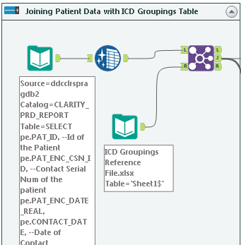

In the beginning I brought in my SQL code that was discussed earlier that holds all the patient data needed. I also brought in my ICD Groupings Reference File to eventually join the two together based on the ICD code so that the general diagnosis would be in my dataset. I cleaned up the code with the blue icon because I wanted to make sure what I was joining together had the same type of casing because Alteryx is a case sensitive application.

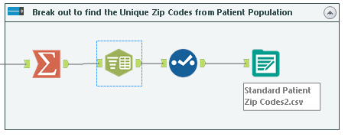

A bit of the main road, but this is where I found my distinct list of zip codes based on the patient population at Bruner. This is where I was able to clean up my zip codes and then pull them out to build my reference table that I will use next which has all the data I need for the social determinants.

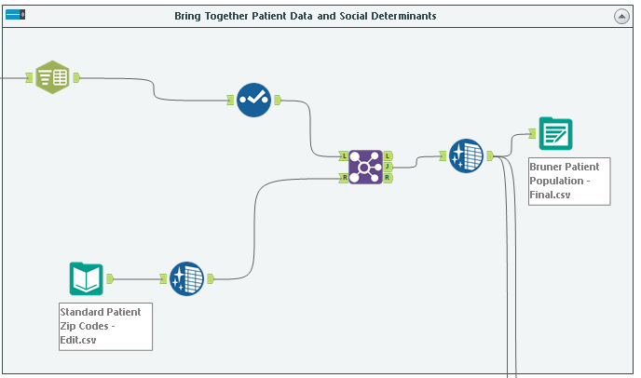

Here is where I brought together my patient data and my social determinants data so that I can have my final dataset, Bruner Patient Population Final. This is the only dataset you will not be able to see because it is Personal Health Information which is illegal to publically display.

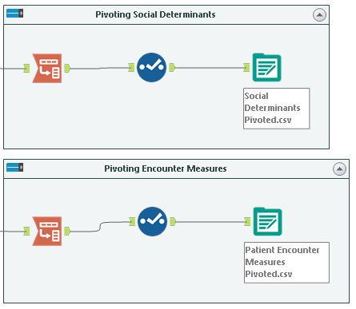

I added these last two components while working on my Tableau dashboards. I wanted to pivot my measures distinctly and I just couldn’t do it in Tableau so I moved the process in here. I have two different ones, one for social determinants and the other for patient encounters, the usefulness of these will be shown later on in my analysis, but the data is in the Building-the-Dataset branch of the repository and the names of the files are: Social Determinants Pivoted.csv and Patient Encounter Measures Pivoted.csv.

## Exploratory Data Analysis

An exploratory data analysis or EDA is a vital step to any data science project. Before being able to model your data in any sort of way it is important to perform a thorough EDA process which allows you to learn about your dataset and to allows you to understand what you have, and what you could be missing which if left unnoticed can derail the project before it truly has a chance. Most EDA processes start very basic but can get more complex the deeper you get into the data, for this project I split my EDA into two parts, the first part is with RStudio, learning some fundamental information about the structure of the dataset; for part two I will be using Tableau to visualize my data further and pull more information out about the patients at Bruner Clinic and about the chronic conditions I’m focused on.

After loading the data and bringing in the RStudio packages we need, we can begin the analysis.

Let’s start by just looking at the dimensions of our dataset:



We see that there are 14,424 total records and 68 total fields within this dataset.

Next we will look at the basic structure of the dataset and its 68 different variables:

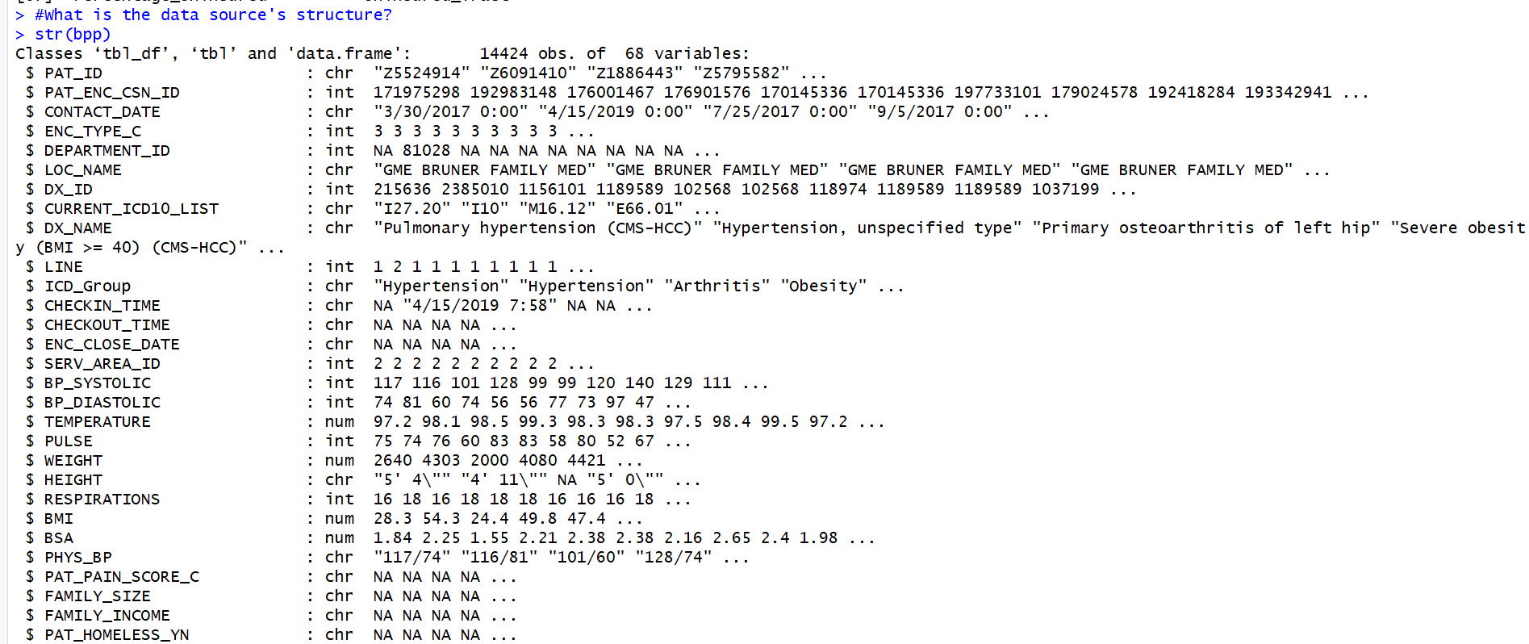

Above is just part of the structure of the dataset, what this did confirm is the number of records and variables within my dataset, but what I didn’t like is that some fields in my dataset were not of the correct data type, I’ll need to change that before I can move forward. The fields I need changed either need changed to character types, numeric types or factor types. The fields that need to become character types: PAT_ENC_CSN_ID, ENC_TYPE_C, DEPARTMENT_ID, LINE, SERV_AREA_ID, STATE_C, COUNTY_C, PAT_MRN_ID, CUR_PCP_PROV_ID, CUR_PRIM_LOC_ID, DX_ID. Variables that need to be changed to numeric: FAMILY_INCOME, FAMILY SIZE. Variables that need changed to factor: ICD_Group, LOC_NAME, ZIP_CODES, SEX_C, ETHNIC_GROUP_C, MARITAL_STATUS_C, LANGUAGE_C, TOBACCO_USE_VRFY_YN.

After making all those changes I checked the structure of the dataset again to make sure the data types were as they should be, the changes were successful and I could move on.

I want to make sure the data was uploaded into RStudio correctly so let’s check the start and end to make sure there isn’t anything funny going on with the data.

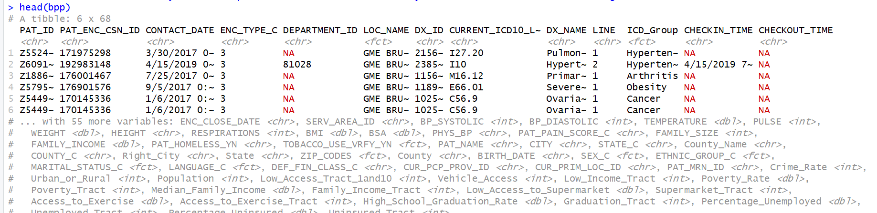

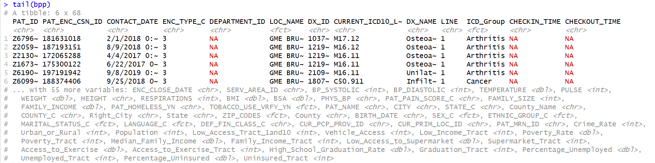

Unfortunately the dataset is too big for just one screen shot but regardless we see that we have a lot of null values within some of our fields. To perform our analysis going forward this is something we must deal with or there will be some definite issues moving forward. We will start by investigating some of the fields and seeing which out of the 68 have null values, than we will decide what to do with them from here.

With R commands we can discover if a field has null values within it, and then we can figure out what we would want to do with them after. I ended up finding 9 total fields which had null values. I’ve decided to just get rid of those variables most of those instead of just getting rid of the null values within them. I did this because none of these 6 were that important to the analysis going forward so it felt the best thing to do was to get rid of them and move on. We can do this by just de-selecting these values out of the dataset like so:

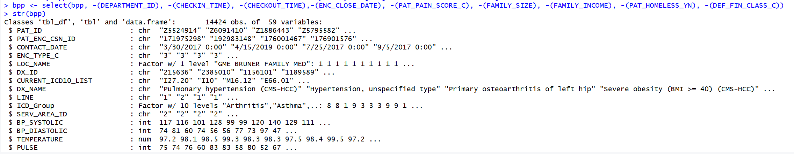

The (-) in front will get rid of those variables from the dataset. We then check the structure to see that we still have our same number of records but we now only have 59 variables after dropping those 9 with null values.

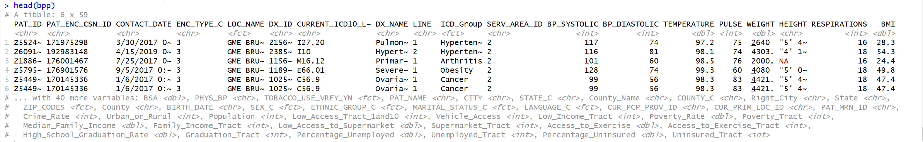

To show a clean dataset, I used the head function again to look at the first few rows and to see if any other variables containing null values showed up.

But with my dataset cleaned up I can continue to explore my overall dataset. Probably the most important dimension I have within my dataset is named ICD_Group. It is the dimension that is from my ICD Code Reference File which helped me bring together all the different codes and funnel them by their specific chronic condition. We can play around with that and see what kind of data we have within it.



Just tabling the results of the dataset were able to look and see how many patients we have for each chronic condition. A little discouraging to me we have two variables with an overwhelming number of patients; arthritis with over 7600 patients, and cancer with over 5000 patients. The distribution between chronic conditions and number of patients is very uneven but I can make it work moving forward.

Another variable that will be important is named SEX_C and this houses the gender of each of the patients. Within our database they have numeric keys. Female = 1 and Male = 2.

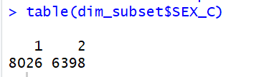

As we can see, it appears we have almost 2000 more female patients than male patients which is surprising in my eyes, I was expecting slightly more male patients than female and I expected there to be a much closer split and not one with such a wide margin.

Another major aspect of my dataset is that I will be using many different metrics to analyze my patients. I want to be able to look at them within a subset, so I’m going to do that just to be able to understand how many measures I actually have in total.

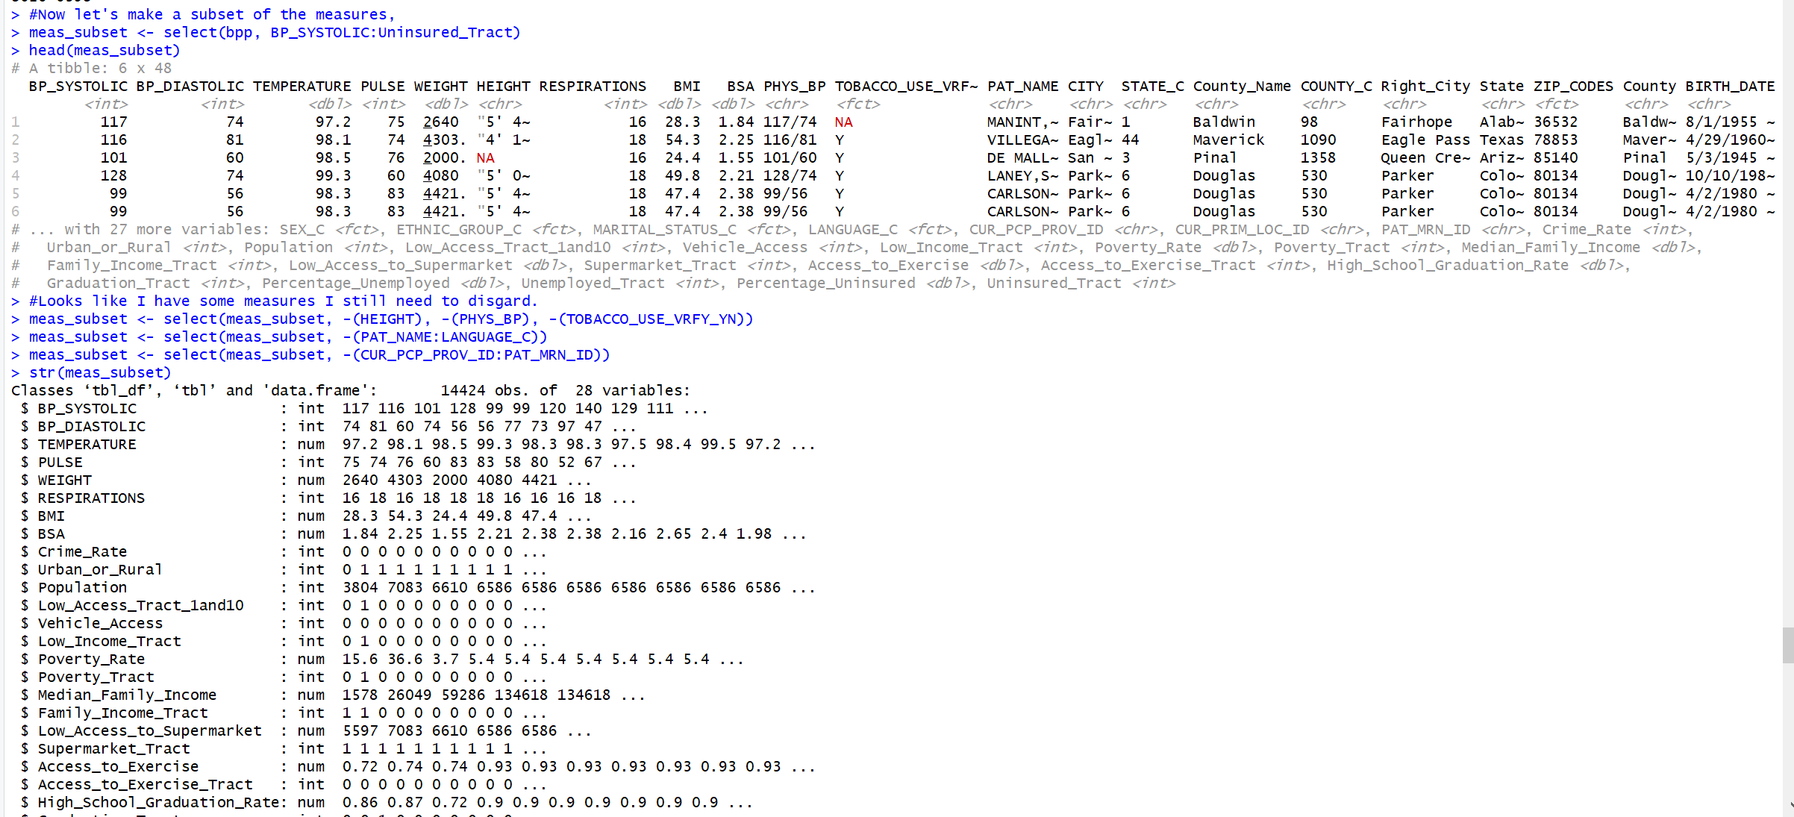

After some configuration I was able to come up with a subset of just measures that will be used within our total analysis. There is a total of 28 of them, which is quite a few but some of them are binary values and will be used in a different capacity than their full ranged data counterparts.

With some slicing and dicing of the dataset it appears I’m in need of trimming down the full dataset so that I can get only the variables I need to perform my analysis. To do this we will need to alter the dataset by only grabbing the necessary variables going forward.



With our dataset that we have moving forward let’s take a look at the distribution of some variables using some visualizations.

Chronic Conditions:

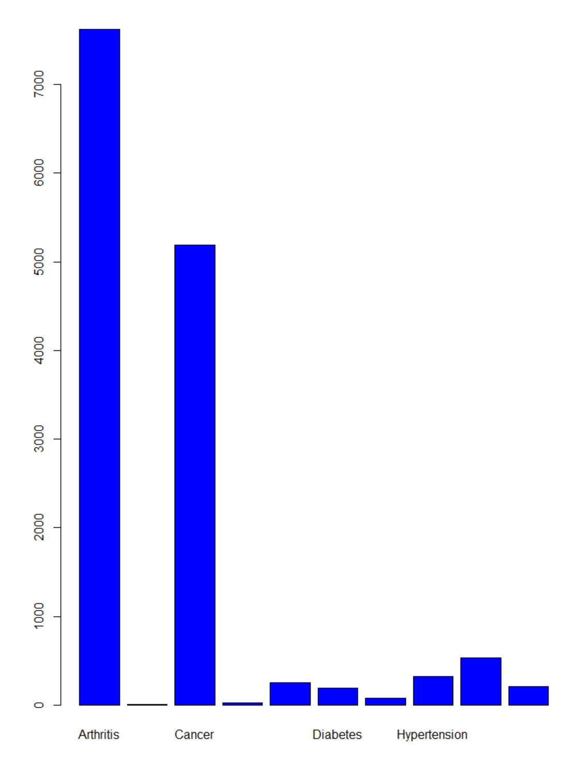

This really puts into perspective how many more arthritis and cancer patients are within the dataset.

State:

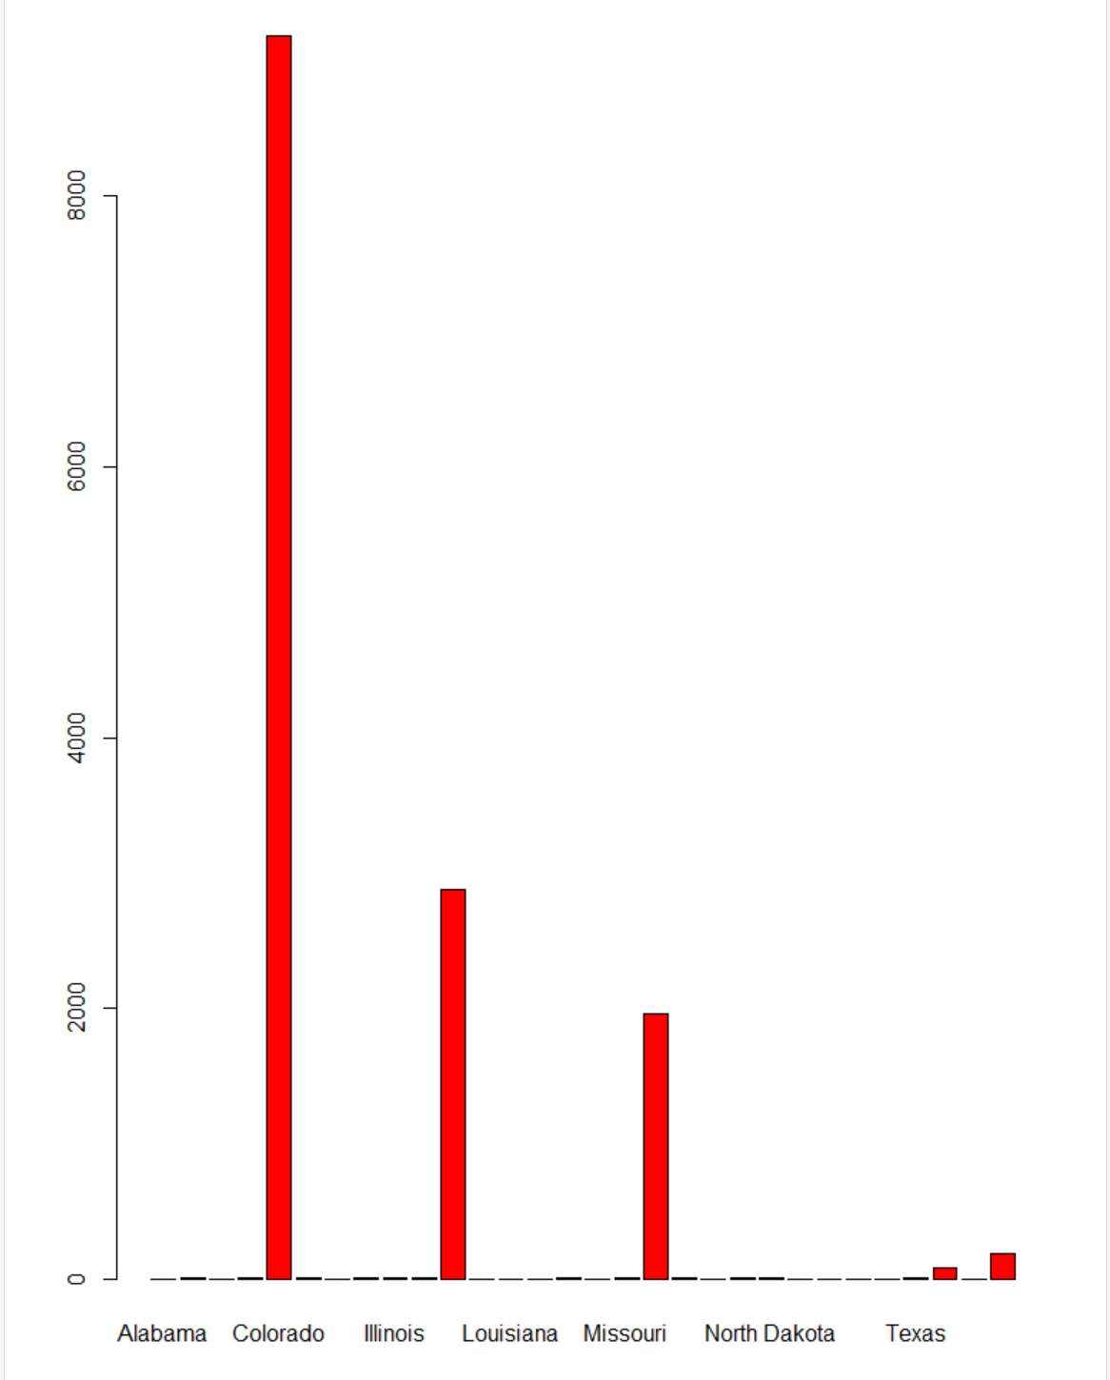

Without surprise a vast majority of our patients come from Colorado, but a surprising amount appear to be from Kansas and Montana as well.

We can also look deeper into the measures as well trying to find any correlation between them by just plotting scatter plots of some of the pairs.

BP_Systolic vs. BP_Diastolic

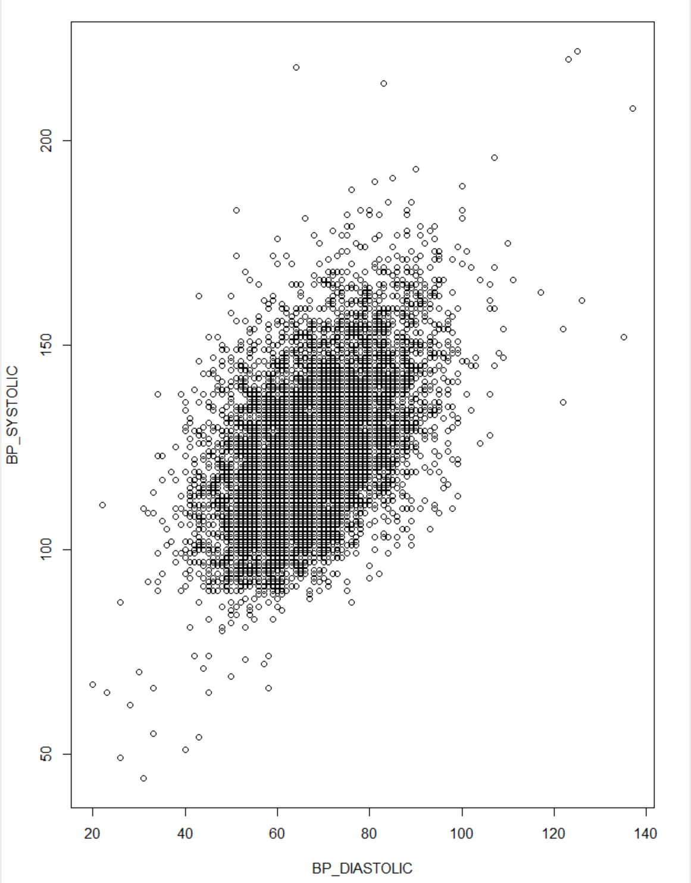

There is an obvious correlation between these two because the higher one blood pressure than the higher the other.

Pulse vs. Respirations

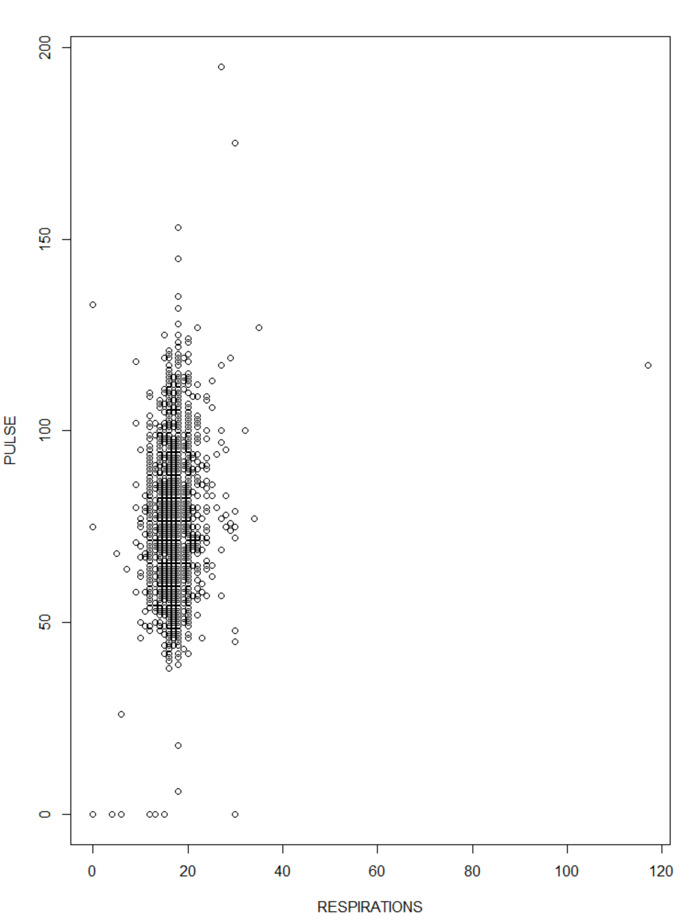

There doesn’t appear to be much correlation here, reason so is because it appears a big majority of the respiration values are huddled around 20 which is about normal with a couple outliers like a patient with around 120 outliers total and a patient also with a pulse of close to 200 bpm.

Another thing we can look into is the distribution of the fields. A great chart for that is using a histogram.

BMI:

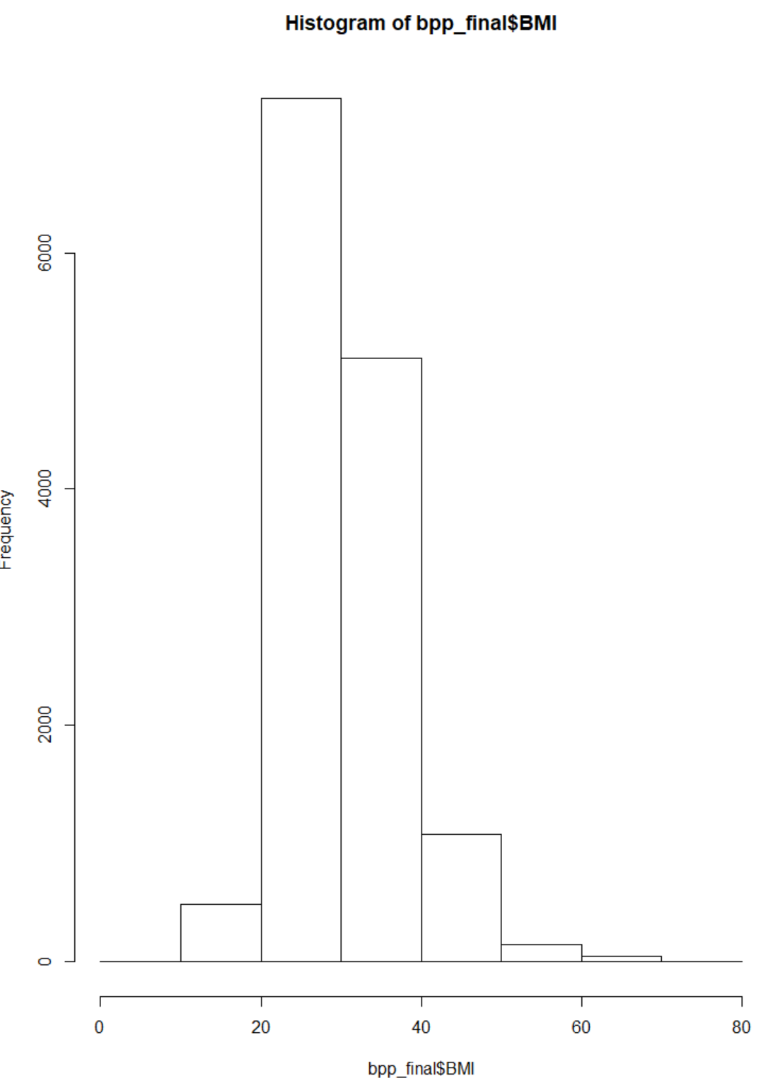

It would appear this data is skewed just a little with a large chunk of values having a BMI between 20 and 30, but the average of the BMI variable appears to be more than the threshold that would state someone is overweight which is over 27.

Poverty Rate:

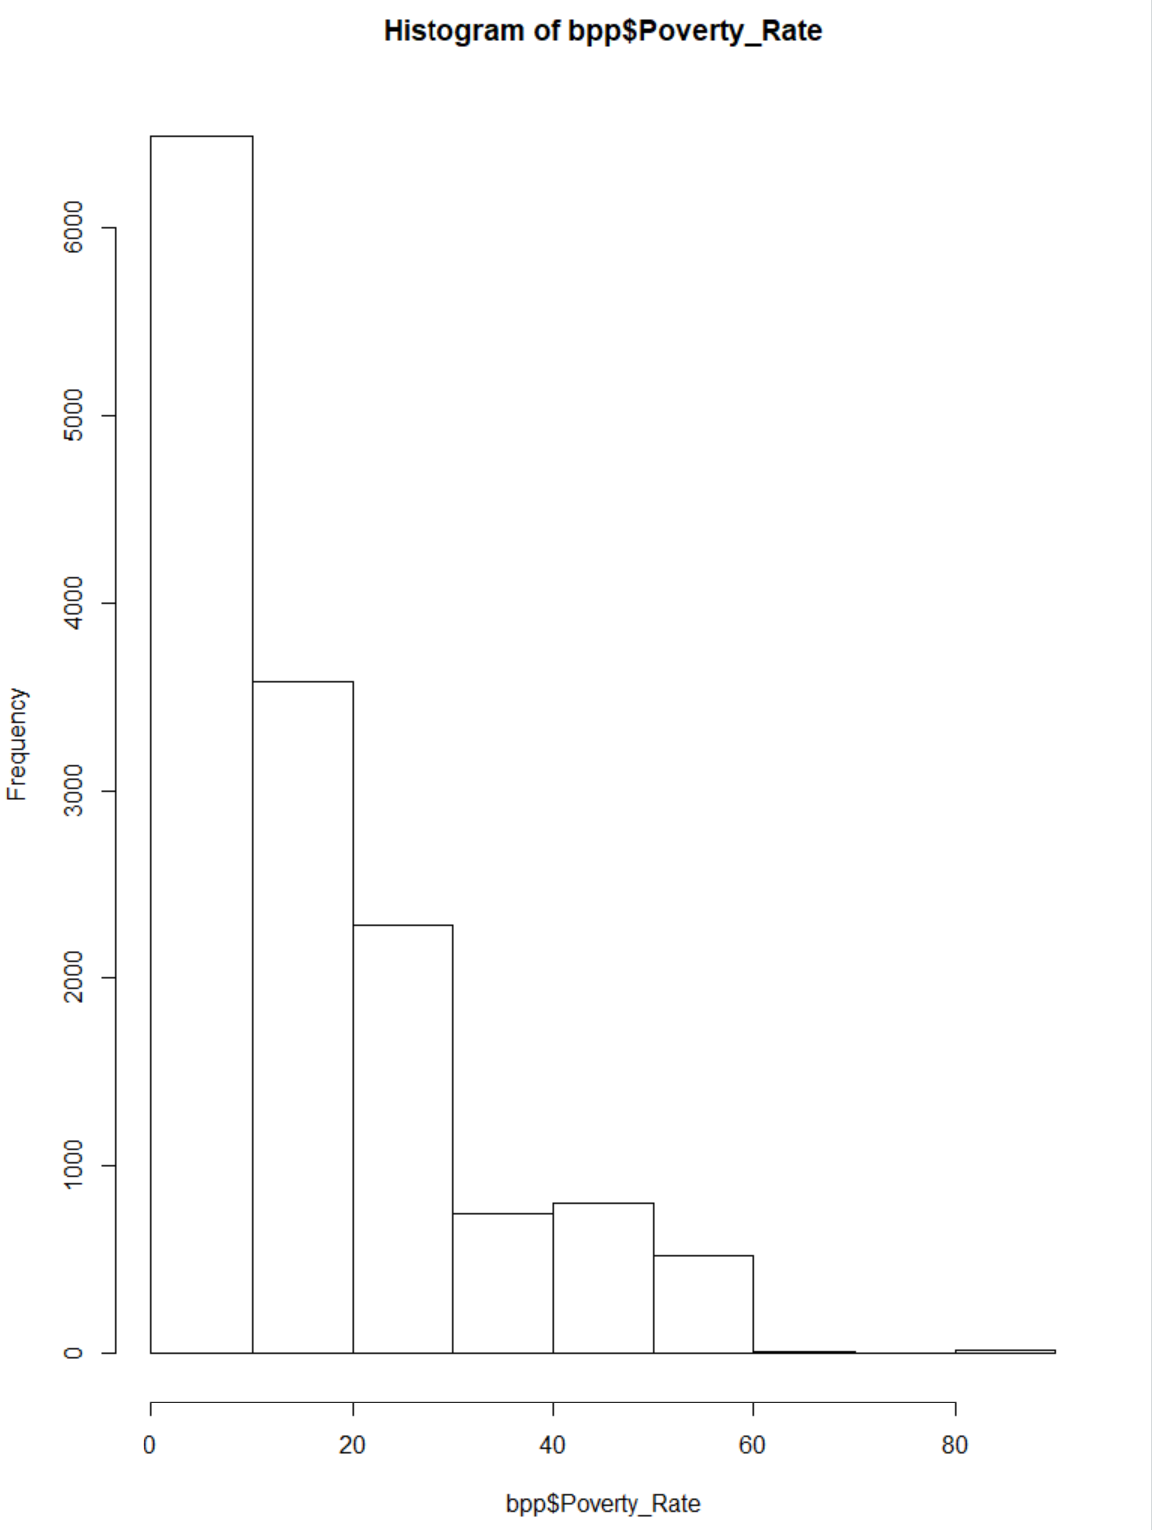

The poverty rate has about 50% of the patients at or below 10% but there is quite a few that will be in the high poverty rate area when we test that later it would appear.

Percentage Uninsured:

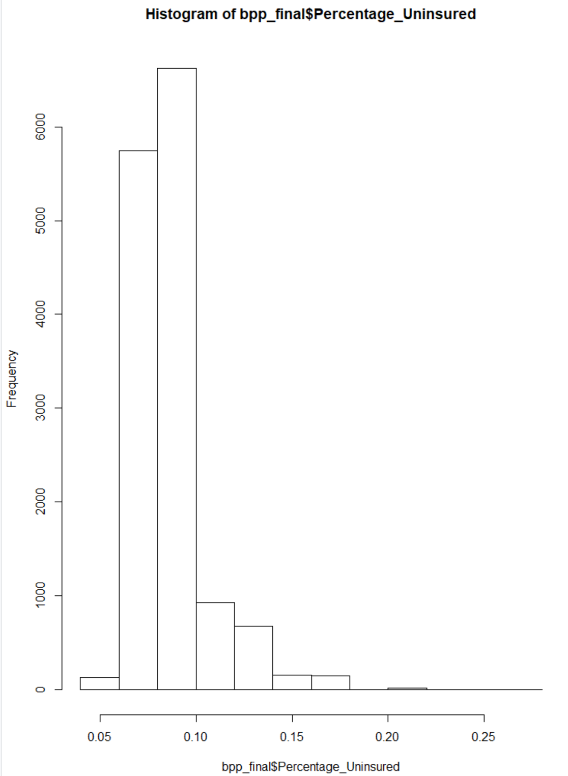

We can compare the distribution of measures across different dimensions. We can compare singular measures based on chronic conditions by using box plots, like this:

Weight vs. Chronic Conditions:

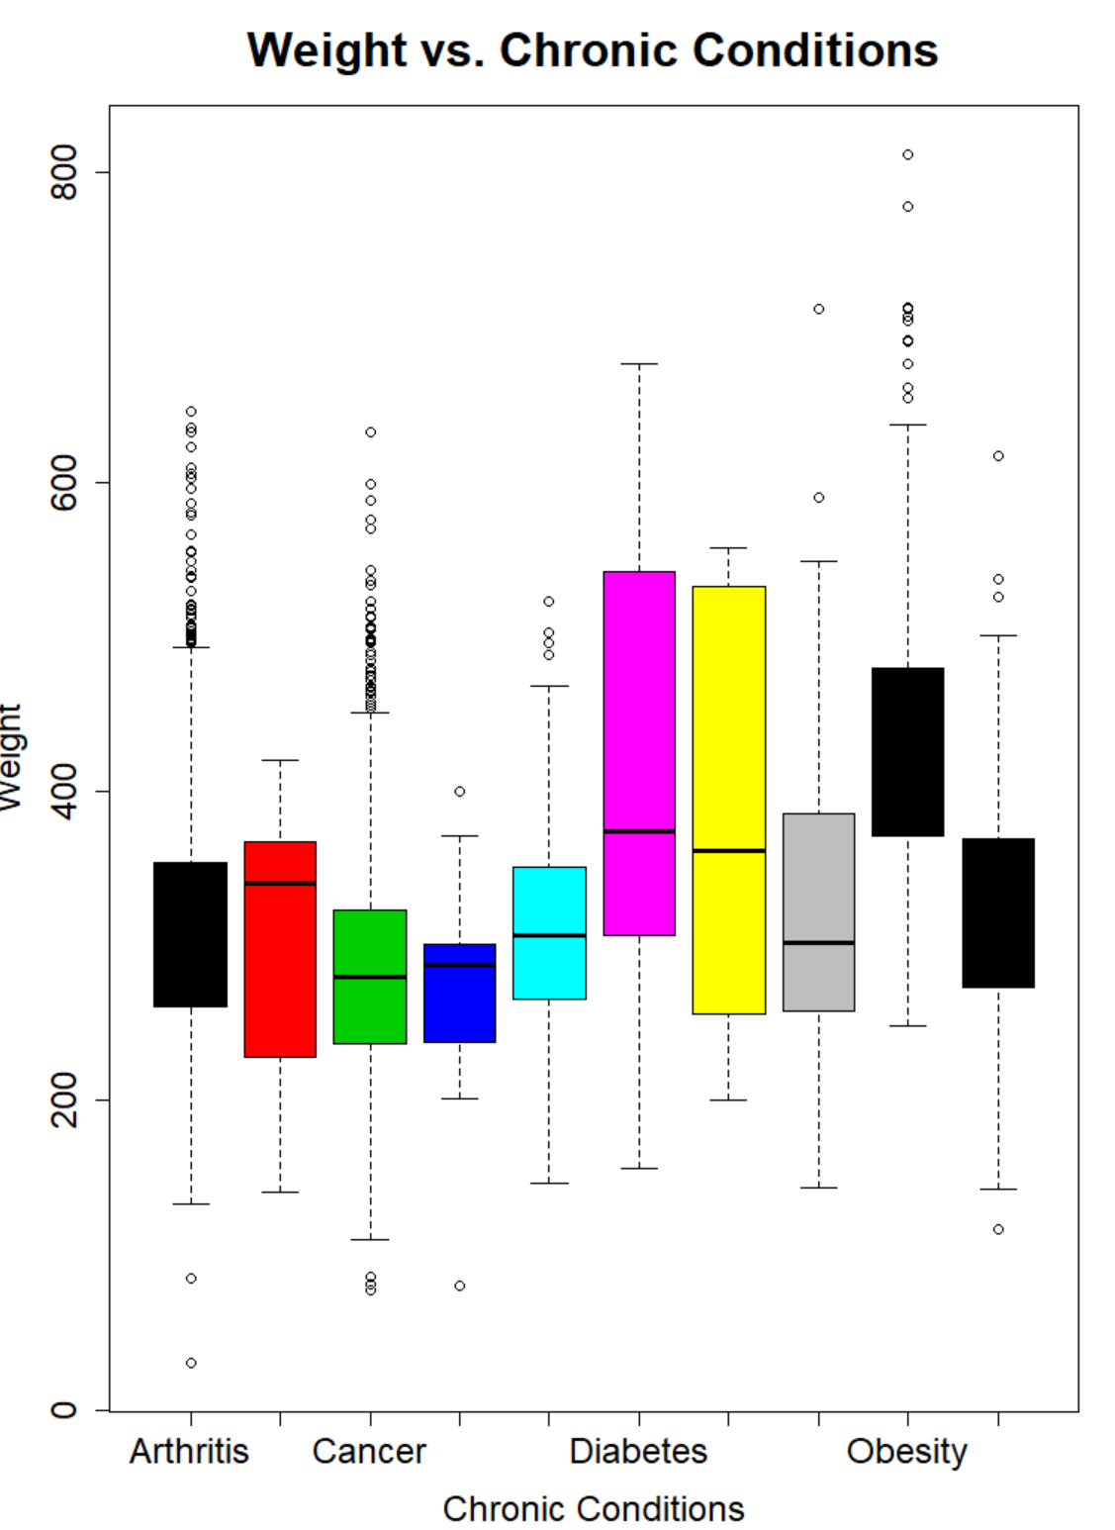

Here we are looking at the distribution of weight across our chronic conditions. What is apparent to me right away is how many patients are over 200 lbs in total and then also seeing how different some of the ranges are per chronic condition. It is really astonishing seeing how different something can be so different across different chronic conditions.

Lack of Exercise vs. Chronic Conditions:

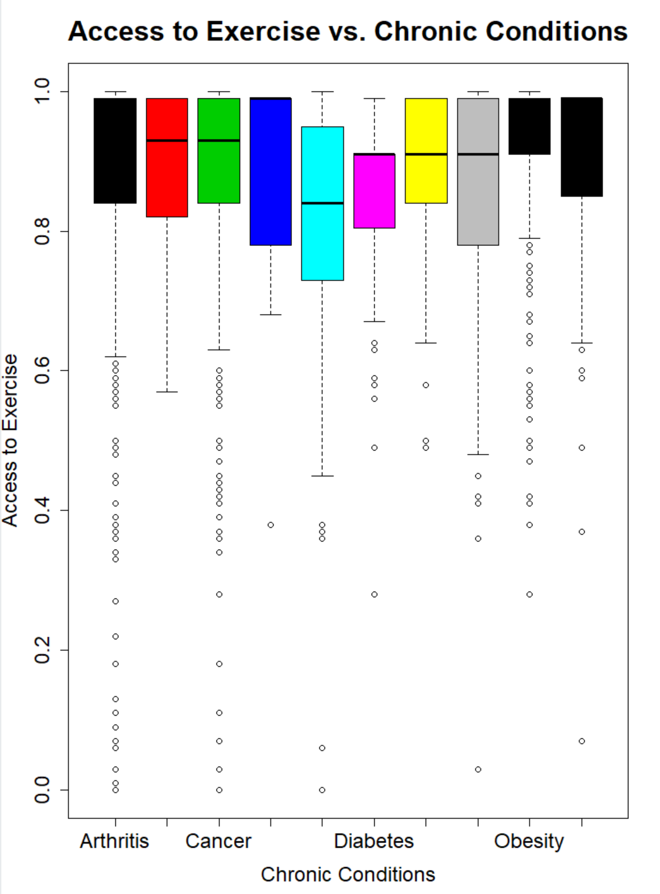

This distribution is quite remarkable, looking at a chronic condition like obesity where the quartile range is as high as could be, and yes there are a lot of outliers but that it remarkable when one of the causes of obesity for people is lack of exercise.

Another interesting way for us to look at our data would be by using something called qplots, which can split out the data based on a specific dimension, than compare the correlation of two variables as well.

Weight vs. Pulse:

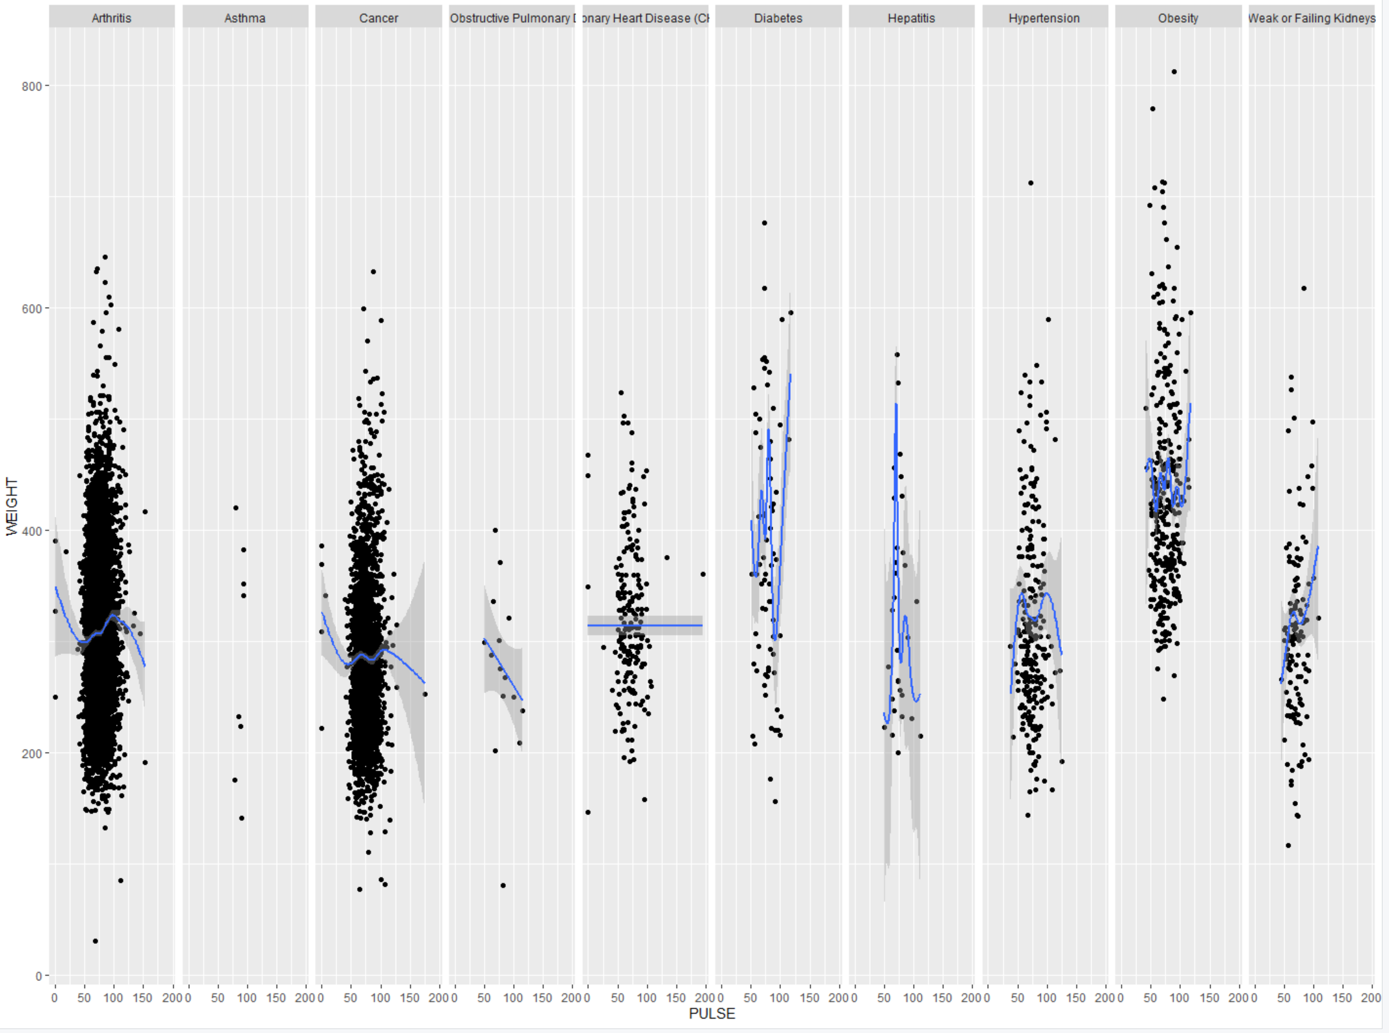

With how different the trend line goes through each of the different chronic conditions, it is clearly evident that the data is different based on that variable for weight and pulse. Let’s look at two social measures and see what result we get.

Median Family Income vs. Access to Supermarket

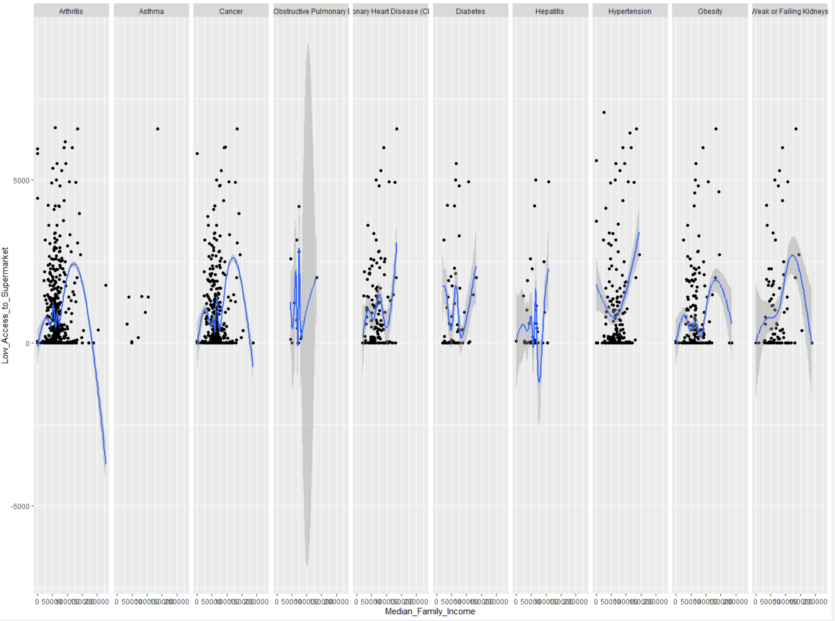

The results here show more variation between chronic conditions when putting two measures together. There are some charts that look similar but there are some variation to these charts depending on the chronic condition. Which makes it very interesting for the analysis going forward.

This is the end of my EDA analysis within R. I was able to find a lot of good information about my dataset and was also able to prepare my dataset for my cluster analysis which I will do soon, but next I’m going to transition over to Tableau to further my EDA process and create some dashboards which can be interacted with by my end users.

## Tableau Dashboards

The Tableau dashboards are designed to give a visual representation to some of the possible trends and outcomes seen within this Bruner patient data. This process was truly a second half of an EDA process that I wanted to run before moving into performing my unsupervised machine learning algorithms to cluster the data.

### Patient Population by County

### 

The first dashboard is focused on gaining insights about the patients and the environments they come from. Gaining these insights could help show if a chronic condition more prevalent in a given area, which could allow us to dive deeper and determine if this is an issue within that environment or just an outlier.

**Filters of the Dashboard:**

State – Filters to show patients that are from that given state.

Chronic Condition – Filter down to one of our 10 chronic conditions

**Built In Filters:**

Patients by County – Click on a county and see only the information pertaining to that state.

Chronic Conditions – Click on a specific chronic condition and look at information only about patients with that chronic condition.

Findings: Patients overwhelmingly come from Jefferson and Denver County, which are the two counties that surround Bruner so that is natural. Interesting to see how many patients were recorded as being from outside the state of Colorado. Arthritis and Cancer are by far the highest counted chronic condition within our patient population.

### Patient Population Overtime

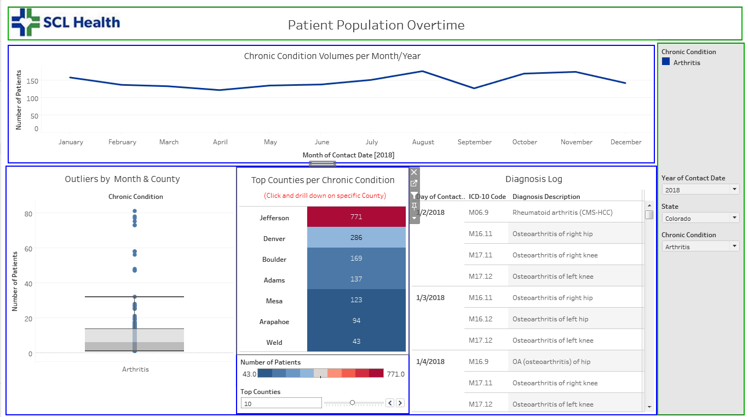

Patient Population Overtime was built to look at any trends that could be within the data. By looking at the trends of a specific chronic condition it is possible to see if there is a recent uptick in a disease in an area or give the chance to find outliers which need to be addressed.

**Filters:**

Year - Filtering the dashboard based on a multitude of years or just 1. Only 2017, 2018 and 2019 are available.

State - Filter by the state the patients are from.

Chronic Condition - Filter based on the patient’s diagnosed condition.

**Built In Filters:**

Top Counties per Chronic Condition – Click a county and see only patients from that county throughout the dashboard.

What is great about this dashboard is were able to see how these chronic conditions have moved and shifted over the last 3 years and were able to do some comparisions from that. Not seen in the screen shot but when you bring in all 10 chronic conditions and compare them too each other, all of the patient volumes are trending down except for the patient population with cancer that actually is rising and has really spiked in 2019 for several counties. We are also given the ability to use the box plots at the bottom left to spot outliers within our data for a given month/year and chronic condition which can help back up any trends we see above or give us better intel on if it is something to worry about.

### Gender Disparity among Patients

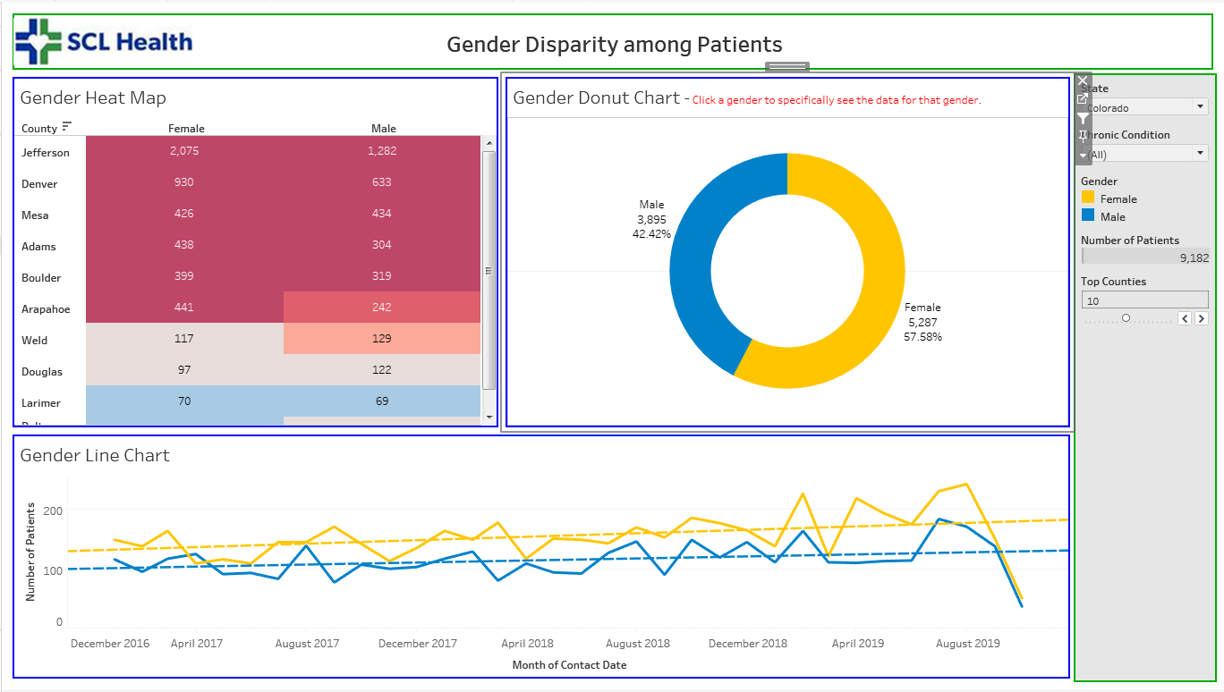

A lot of times within healthcare we see many disparities between genders in healthcare. This dashboard is designed to compare male and female patients across not only locations but by chronic conditions as well.

**Filters:**

State – Filters patients by the state they reside in.

Chronic Condition – Filters patients by what chronic condition they were diagnosed with.

**Built In Filters:**

Gender Donut Chart – Filters based on if the patient wants to only look at Male Patients or Female Patients.

Some interesting findings I found from this dashboard is how many more patients are female and not male, it is close to 16% difference between the two overall. If you look at the individual chronic conditions only a couple of them actually have more male patients than female and those are asthma, COPD and CHD.

### Ethnic Groups and Chronic Conditions.

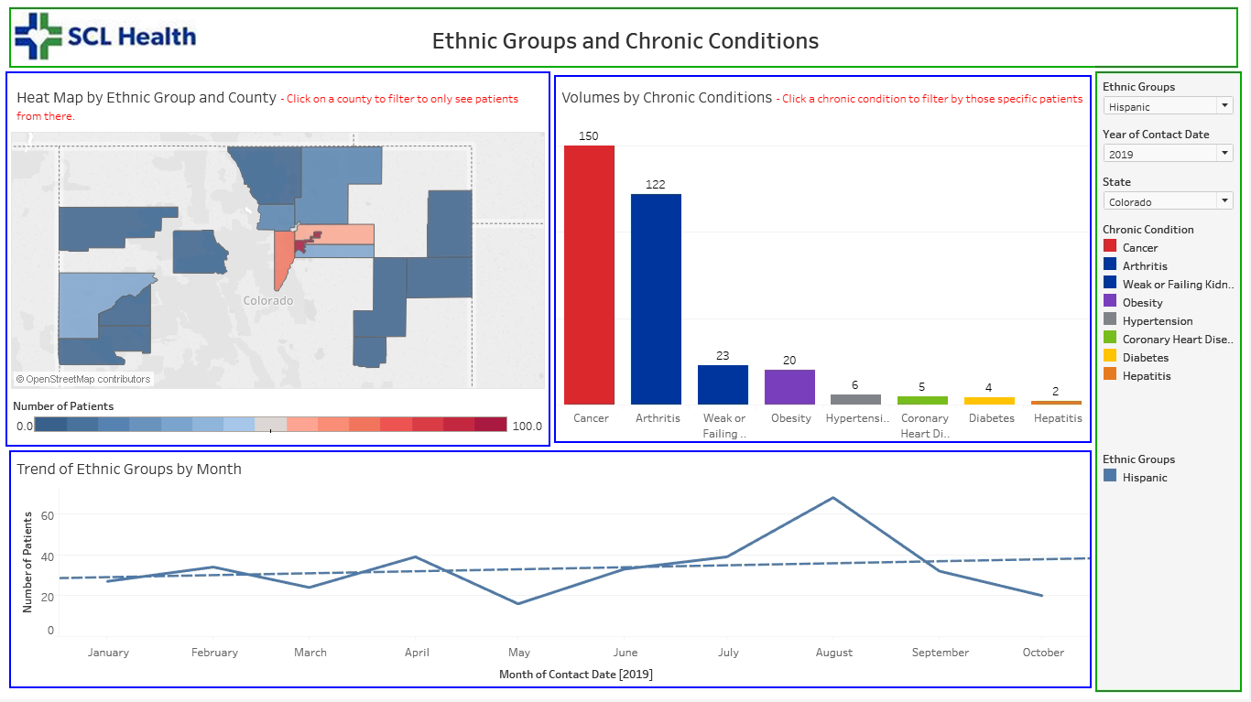

It is important in healthcare to understand the differences you see within a patient population and gender is one of those dimensions to look upon. Within the SCL data we only see patients that are either labeled as Hispanic or Non-Hispanic, which is a shame because were unable to look into other ethnicities further but we are able to look at the Hispanic population and give a good assessment of those people.

**Filters:**

Ethnic Group – filters patients based on if they are either Hispanic or Non-Hispanic.

Year – Allows user to filter based on the year(s) they want to look at.

State – Filters down to the patients and where they come from by state.

**Built-In Filters:**

Heat Map by Ethnic Group and County: Tap on a given county to see the patient population for that given county.

Volumes by Chronic Conditions – Look at the overall volumes of patients with the given chronic conditions.

When looking at this dashboard I found it interesting the similarities between both ethnic groups overall, both look to be trending up over the last 3 years in several of the different chronic conditions. There also wasn’t a big difference in the types of chronic conditions patients had either, both were still proportionally either cancer or arthritis patients.

### Breakdown of Patient Population by Age Groups

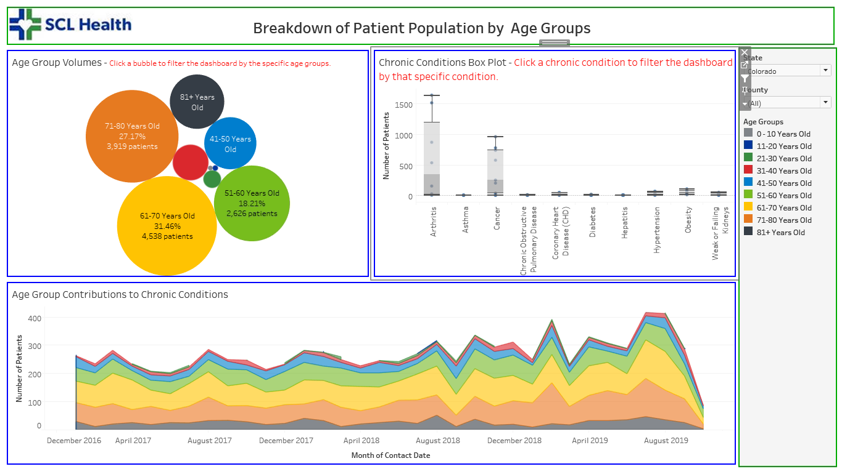

Looking into our patient populations is very important to the clinicians at Bruner clinic because it can tell us a lot about what we should be expect to see for our different chronic conditions. So if an age group is really high for a general chronic condition and that age is abnormally young, finding out that information could be paramount to helping out this group of people.

**Filters:**

State – Filters the patient population by the state they live in.

County – Filters the patient population by the county they are from.

**Built-In Filters:**

Age Group Volumes – Clicking on a bubble will change the dashboard to only show patients from that selected age group.

Chronic Condition Box Plot – Selecting a chronic condition will give you the data for just those patients with that given chronic condition.

I was surprised with the age groups of our patient population. It didn’t appear that any group had an outlier number of patients from a given group for a given condition, no group was abnormally high by volume either.

### The Effect of the Social Environment on Bruner Patients

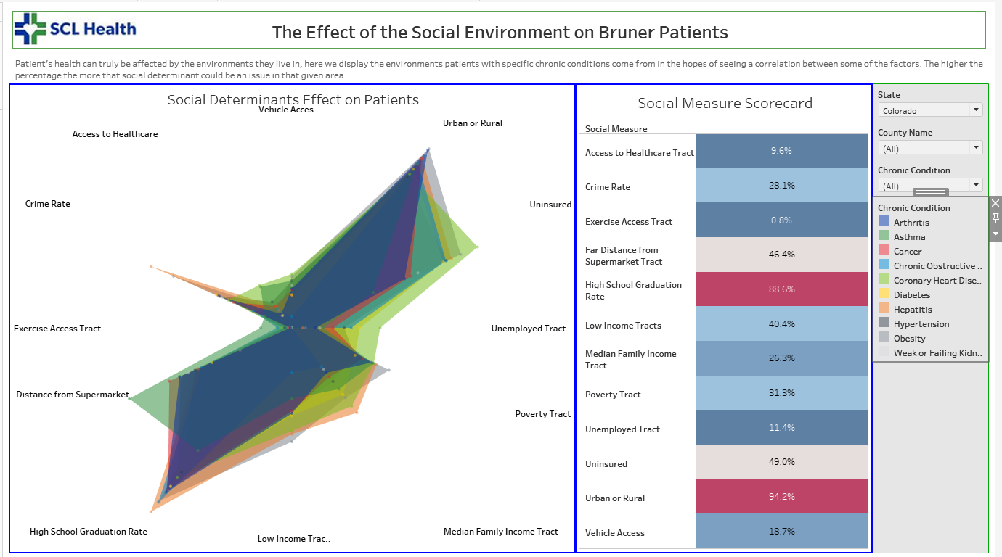

The goal for this dashboard was to take the different social determinant metrics collected for the patients and construct a visualization that shows based on the chronic condition and our filters, what are social factors are these patients prone to within a given state and county.

**Filters:**

State – Filter by a given state for which patients are from.

County Name – Name of the county patients reside in.

Chronic Condition – Filter by a specific chronic condition.

**Highlighter:**

By the legend on the right of the dashboard a user is able to focus on a given chronic condition while shading the others into the background. It allows there to be a comparison between the chronic conditions but you are able to focus on one at a time.

The social determinants in healthcare fascinate me and within this visualization that appears to hold true. If a group of chronic condition patient’s mark as high for a given social determinant then it means those patients are from areas where it is likely for them to be negatively affected by the given measure. The score card was also a great because it gives an exact percentage of how many patients with a given chronic condition are affected by a given social measure.

### Patient Vitals per Chronic Condition

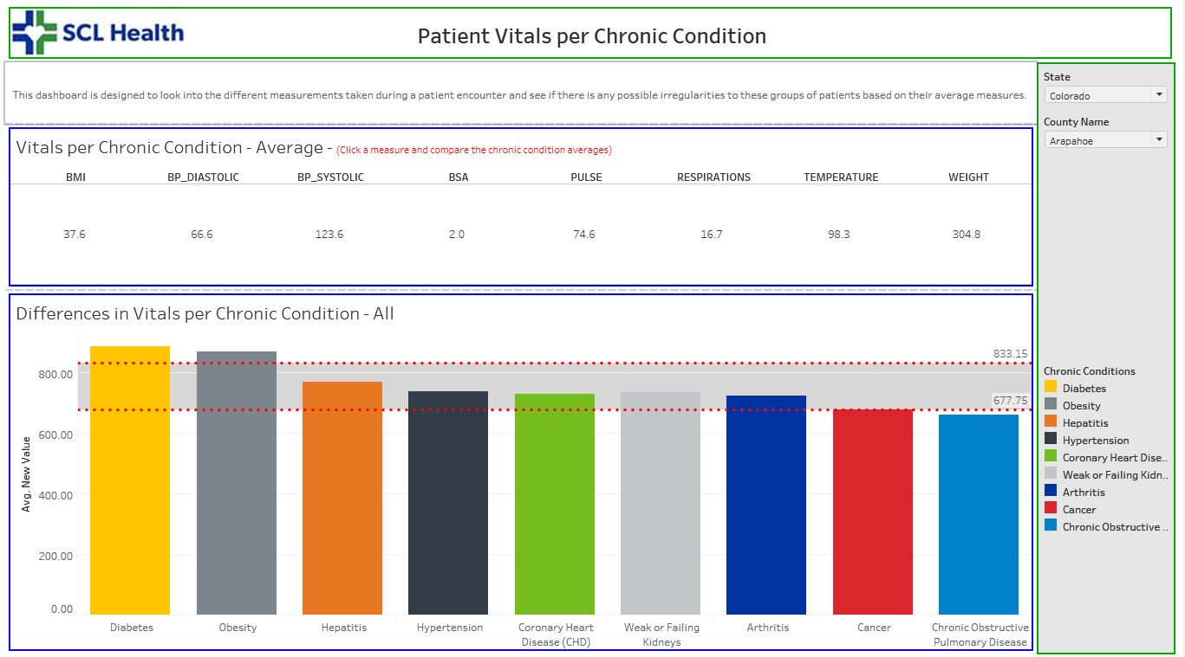

Whenever a patient has an encounter at a hospital there will be measurements taken also known as patient vitals. These are measurements recorded at the hospital and can give insight to why a patient may be feeling any certain way.

**Filters:**

State – Filter patient’s by the state they reside.

County Name – Filter patients by the county they reside.

**Built-In Filters:**

Vitals per Chronic Condition – This is the list of the average value of the given vitals. If you click on one, it will filter down to give the average value per chronic condition and adjust the order of those chronic conditions from greatest to least.

This is an interesting dashboard because it can give insights to what we see as normal and what we could possibly be seeing that is abnormal from a given metric and from a given chronic condition. The standard deviation row banding allows for there to be a capture of patients that may have an abnormally high or low vital based on comparing it to other chronic conditions. This doesn’t state that a patient isn’t at all fine or ok but it does give insight to what is different about the chronic conditions based on the different vitals measured at hospitals.

## Cluster Analysis

There are two main types of cluster analysis that are practiced, both are unsupervised machine learning algorithms and are great for learning about a dataset and its capabilities for any sort of data modeling that you may hope to do in the future. Before my cluster analysis, I want to look at only a select group of variables, I want to focus on the chronic conditions of patients so I will have that variable. Then I will only be using a select group of measures for my cluster analysis. I am going to drop my binary-measures as well, that way I have only rates and volumes within my dataset. This leaves me with only ICD Group and then the measures: BP Systolic, BP Diastolic, Temperature, Pulse, Weight, Respirations, BMI, BSA, Population, Poverty Rate, Median Family Income, Low Access to Supermarket, Access to Exercise, High School Graduation Rate, Percentage Unemployed, and Percentage Uninsured.

### Prelude to Clustering

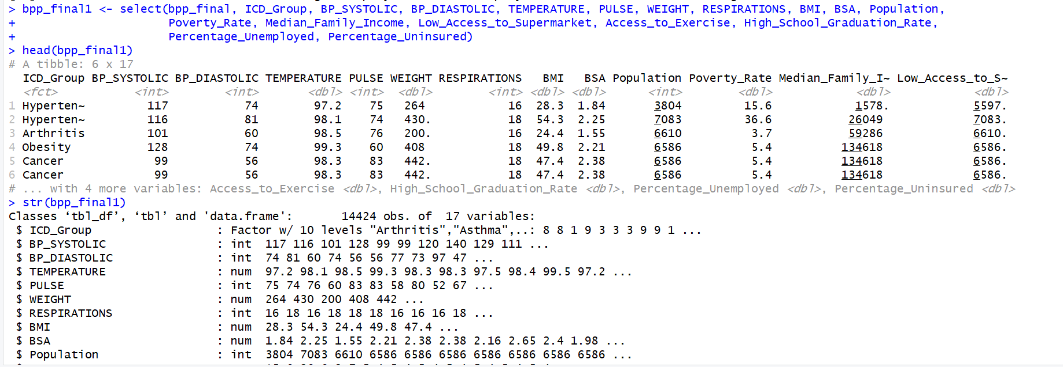

After the changes, I want to look at the correlation of these variables, before moving forward let’s do that with correlograms. These types of charts will give us one view and measure the correlation between each combination of variable pairs.

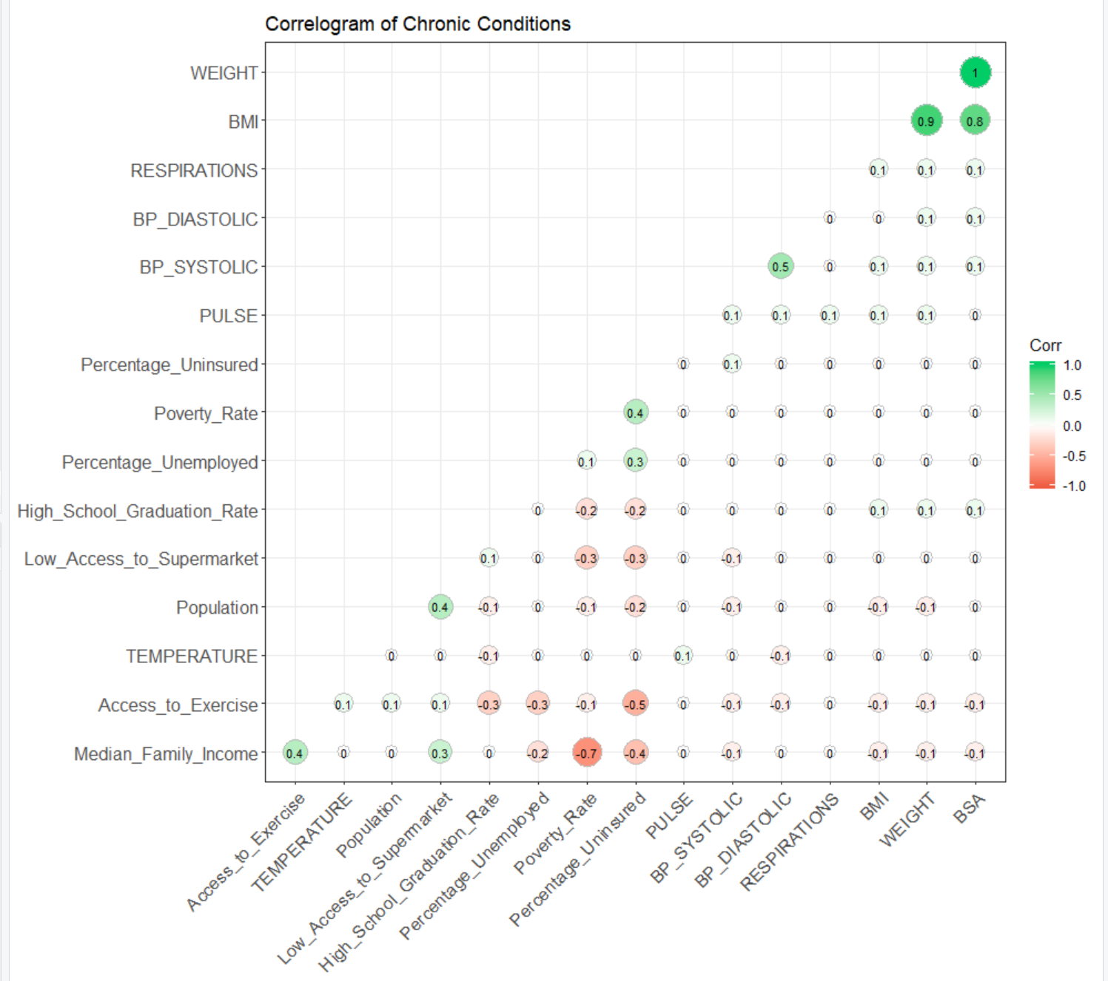

There appears to be plenty of variables that have no correlation, but we also see some that do. We can validate these findings with another correlation matrix.

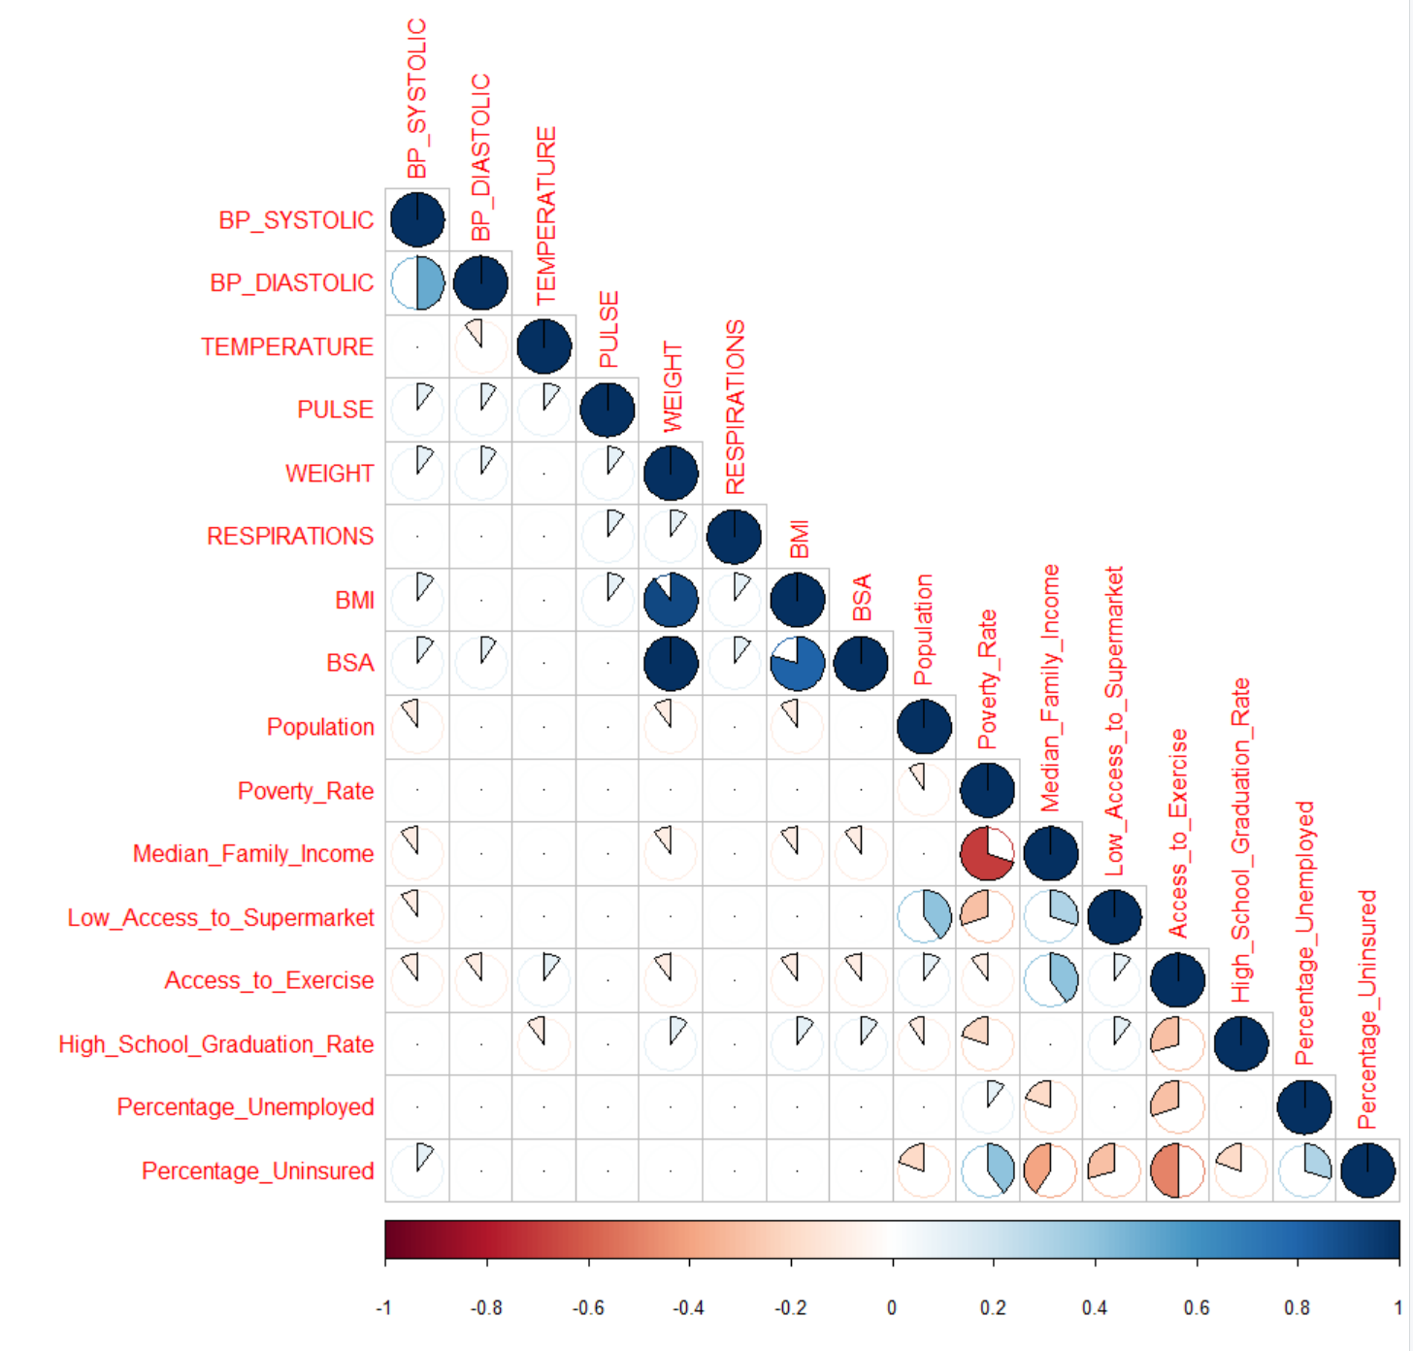

Though we don’t get the decimal numbers of correlation like in the correlogram, we do see a lot of variable pairs that appear to have a strong correlation that is either positive or negative. These pairs appear to be positive for: Blood Pressure Systolic and Diastolic, BMI and Weight, BSA and Weight, BSA and BMI, BSA and Weight, Low Access to Supermarket and Population, Low Access to Supermarket and Median Family Income, Access to Exercise and Median Family Income, Percentage Uninsured and Poverty Rate, and Percentage Uninsured and Percentage Unemployed. The negative correlations that appear strong: Median Family Income and Poverty Rate, Low Access to Supermarket and Poverty Rate, High School Graduation Rate and Access to Exercise, Percentage Unemployed and Access to Exercise, Percentage Uninsured and Median Family Income, Percentage Uninsured and Access to Exercise. These different correlations will be a definite focus moving forward with our analysis. These pairings will be interesting to see if they will carry out with our clusters at all when we are doing our k-means clustering.

### Hierarchical Cluster Analysis

Hierarchical Cluster Analysis (HCA) is a method of cluster analysis which builds a hierarchy of clusters based on the similarities between the variables. The clustering is presented using a dendrogram, and we will be using the divisive method which will take our dataset as one and then eventually break it out into individual data clusters, our objective is that the data points which are of like chronic conditions will be in the same general clusters before finally breaking out to individual data points. With over 14,000 records this will be hard to see by labeling so coloring by chronic condition will be very important as well.

We can start by looking at just the clusters in a pairs plot to see what we could expect from our data moving forward.

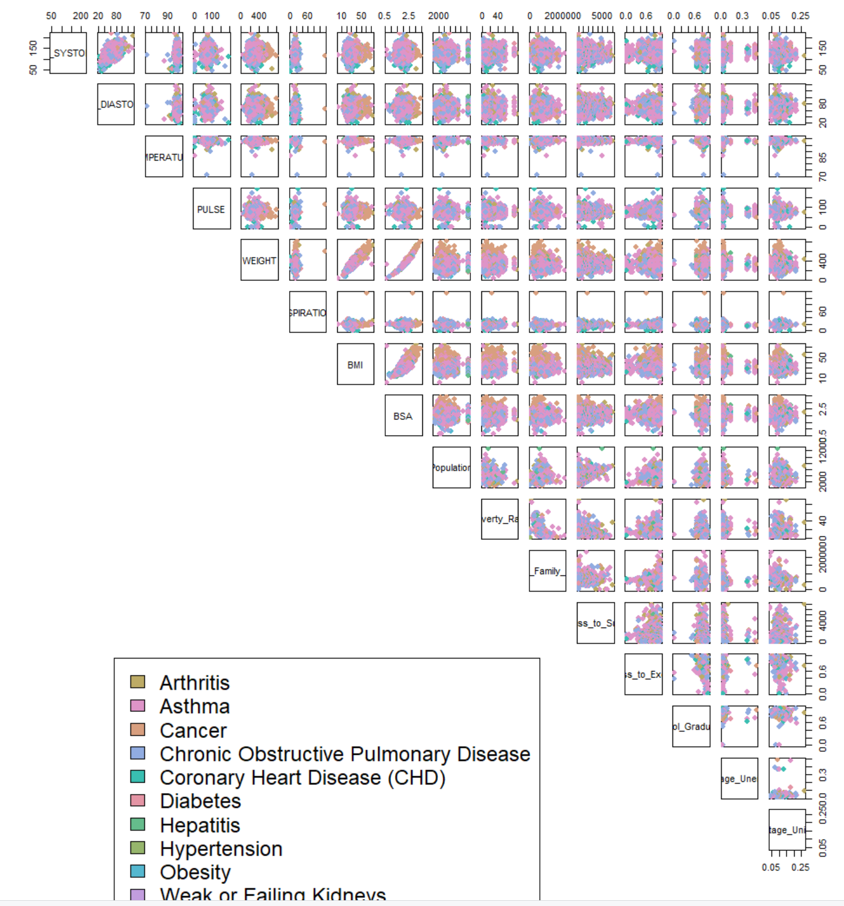

The legend is important because it will be something these colors throughout our HCA. The data points look to be very clustered together, which is a bit discouraging for our future but we can test our data points again by using parallel coordinates for each measure and compare the chronic conditions that way.

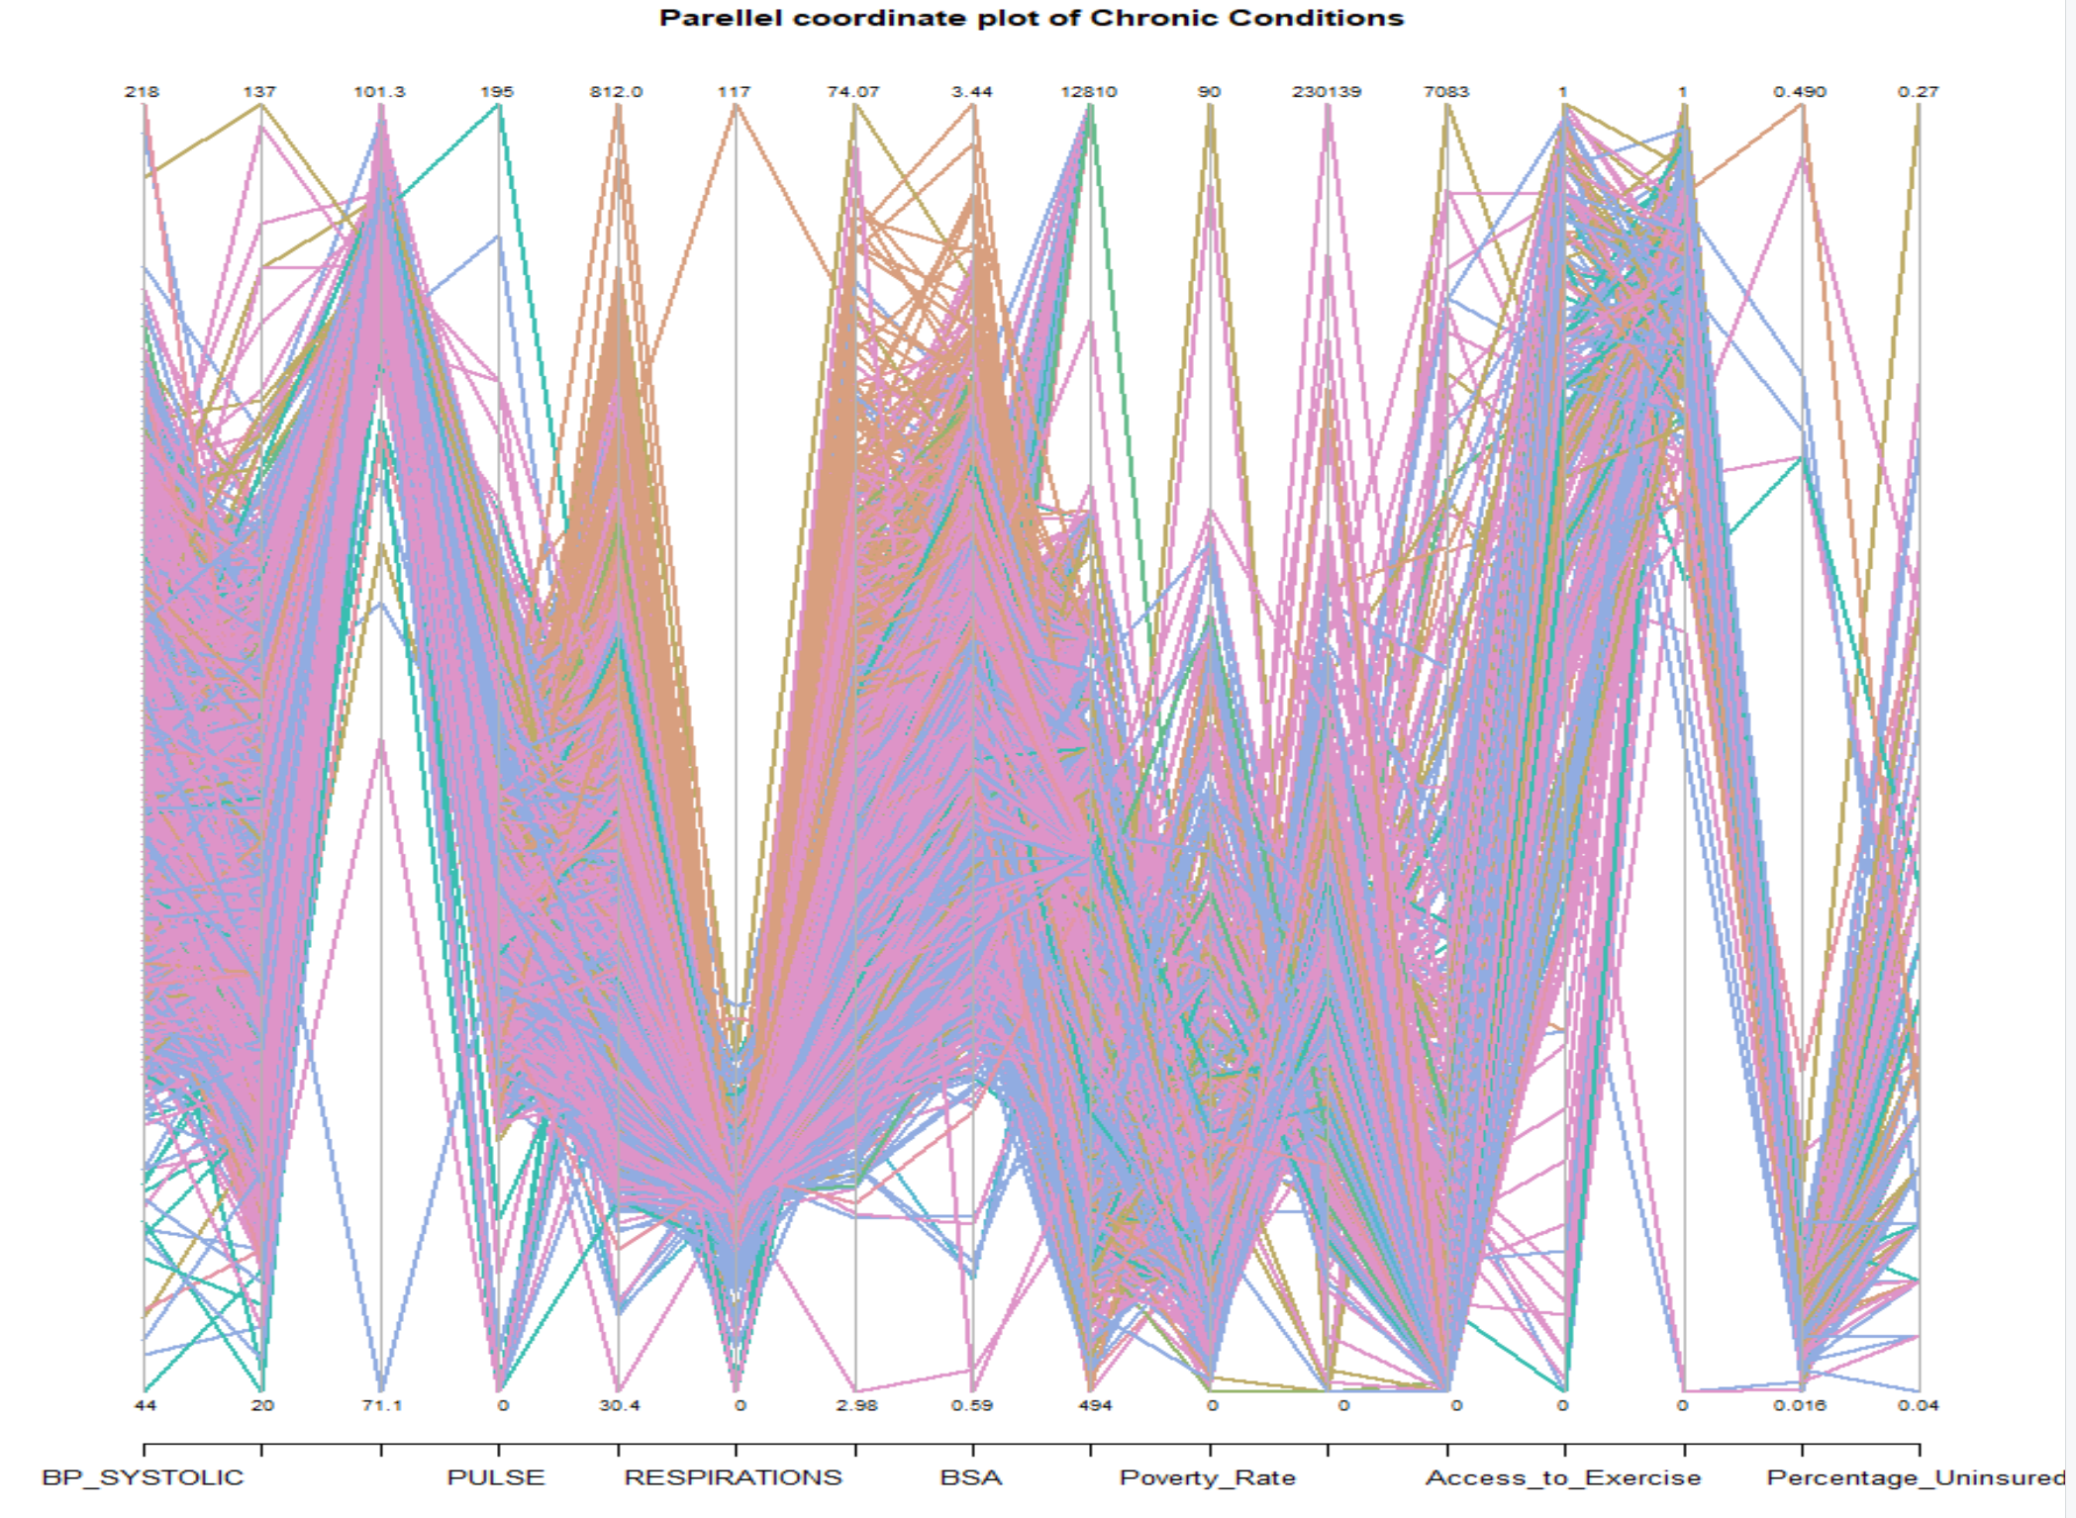

When we look at the parallel coordinates we see some continuity again with our data points and which ones are heavier towards the max or minimum of a given measurement. The outliers are very prevalent in some because there isn’t much disparity between these different conditions. With our testing done, let’s move into creating a dendrogram for our dataset.

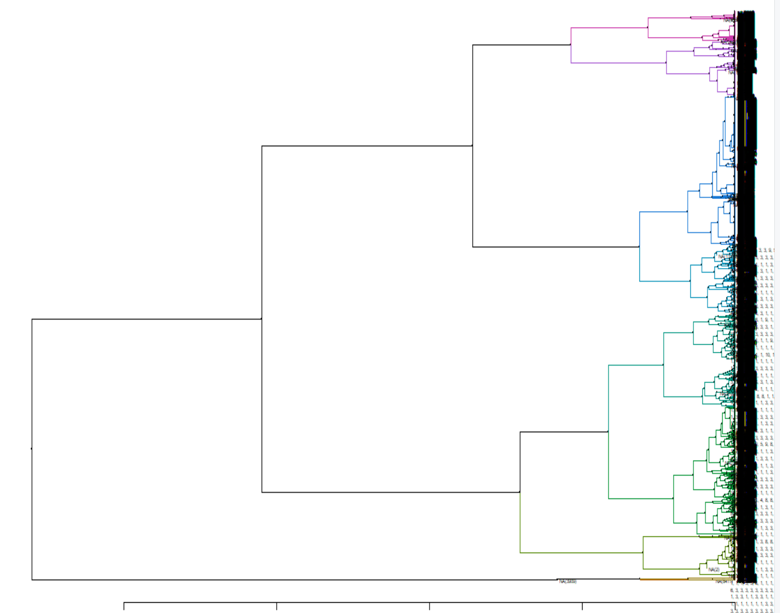

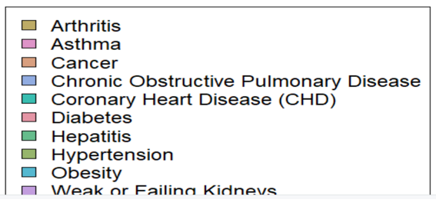

From the dendrogram we went from having the dataset as one giant cluster and broke them out as individual clusters for each dataset. It would appear that there number of iterations we saw our dendrogram perform is around 10, once we get to the end the iterations appear to really bunch together. From our group our 4th and 5th level iterations we can start to pull some information from our cluster analysis though thanks to our color coordinating. We see a good mix of our patients finally breaking out based on their chronic conditions by their the fourth iteration, which is encouraging to see because that could mean there is a distinction in what we are seeing between the chronic conditions.

We can see how these chronic conditions are affected by different measures. We can do that by inserting a heat map with our dendrogram to map how they clustering together. Our issue here is that our measures are on multiple scales so if we don’t do this carefully we can throw off our measure quite a bit. So what we can do to combat this is group our metrics so that it will be easier to see these differences.

Group 1 will include BP Systolic, BP Diastolic, Temperature, Pulse and Weight.

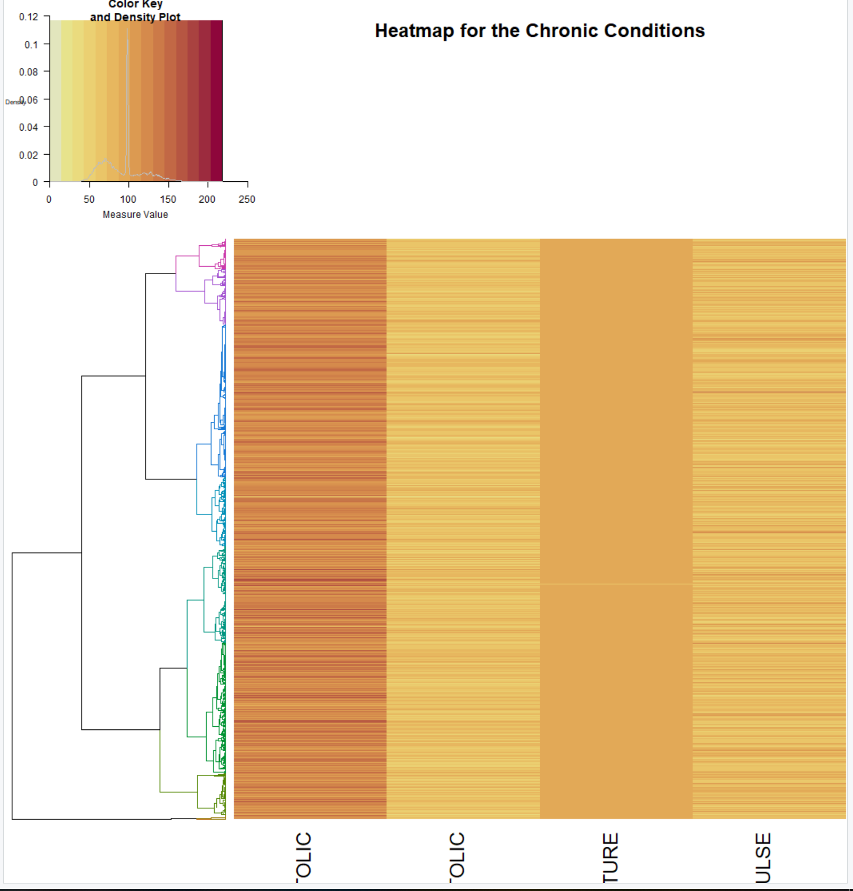

Group 2 will include Respirations, BMI, BSA, Poverty Rate

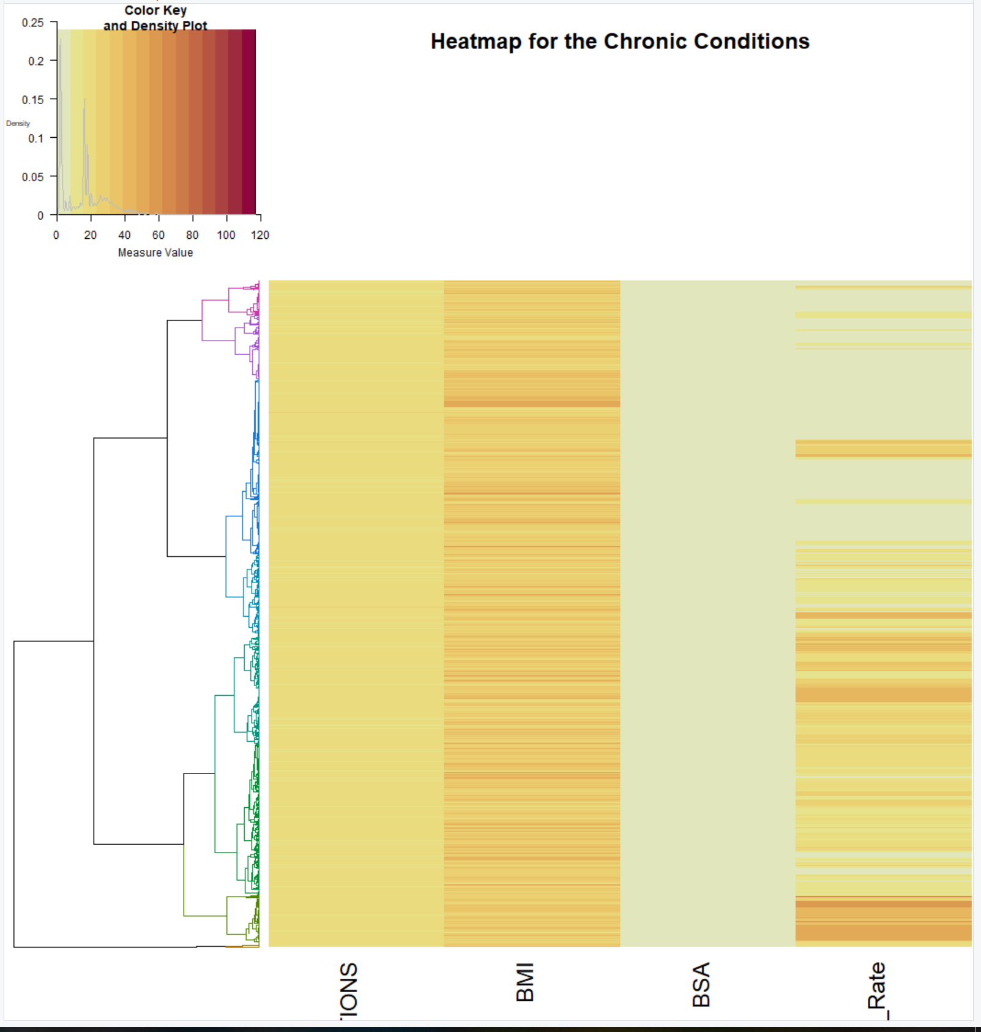

Group 3 will include Population, Low Access to Supermarket and Median Family Income

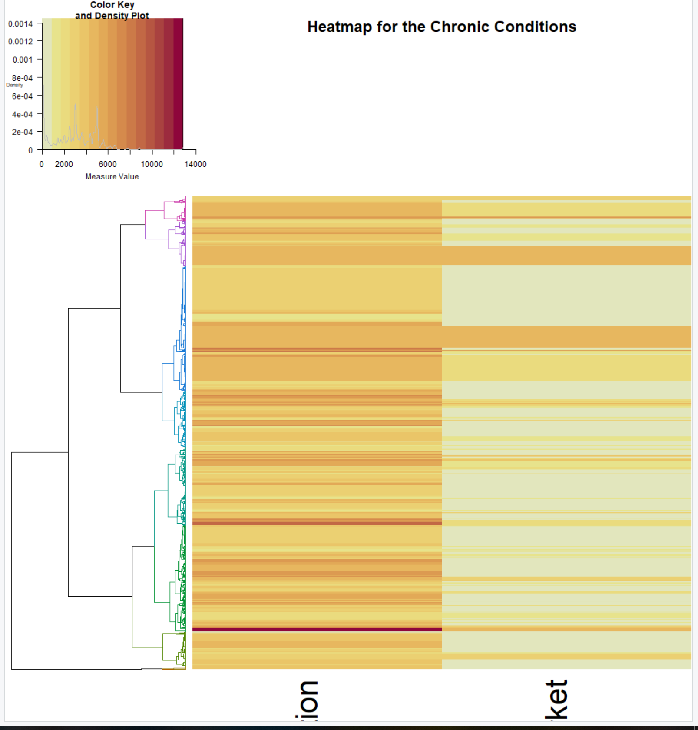

I ended up discarding Median Family Income because it was such a big metric.

Group 4 will include Access to Exercise, High School Graduation Rate, Percentage Unemployed, and Percentage Uninsured

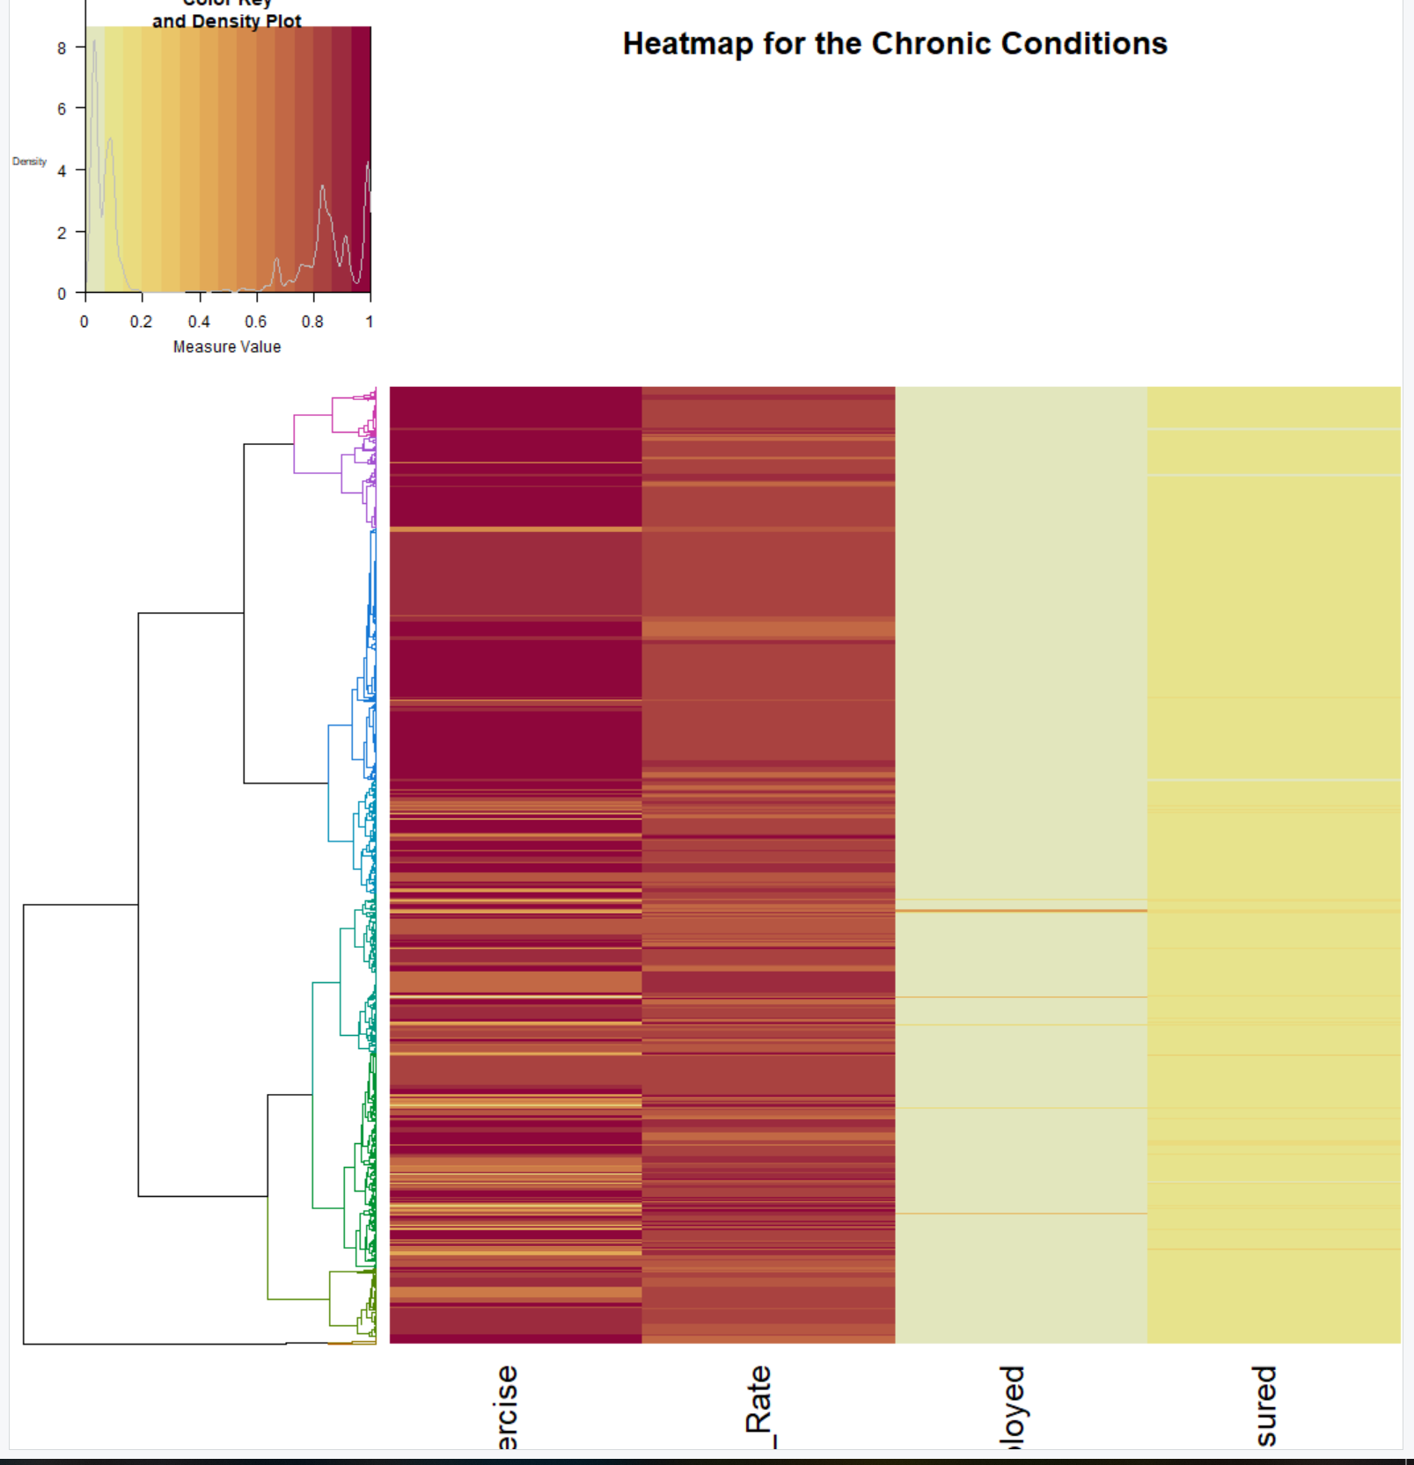

Now we can see how each of the variables effect each of the clusters, and it would appear that that each cluster has a bit of randomness when it comes to the different variables that could be key to determining if a patient has a different chronic condition compared to others. It be also a case where we need to look at the techniques were using for this HCA, there are 8 of them so we could see something else from one of the others.

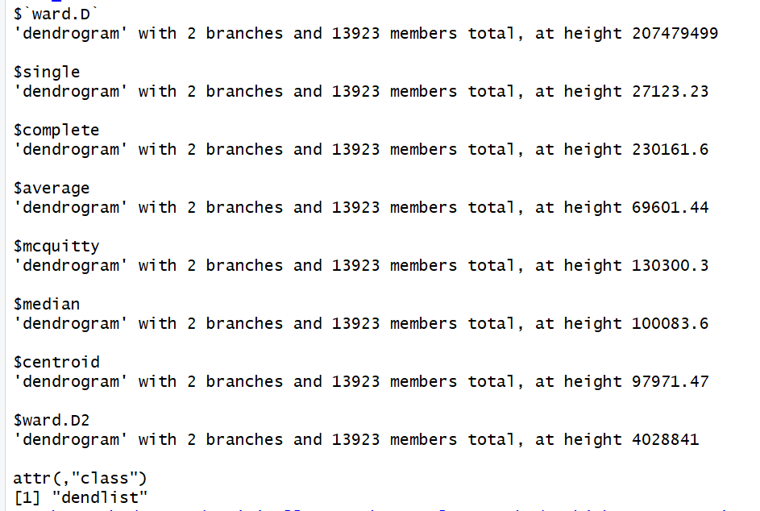

The method I originally used was the complete method, which as over 230161.6 for a height which is one of the lower ones but let’s look at each of the methods as a dendrogram and compare.

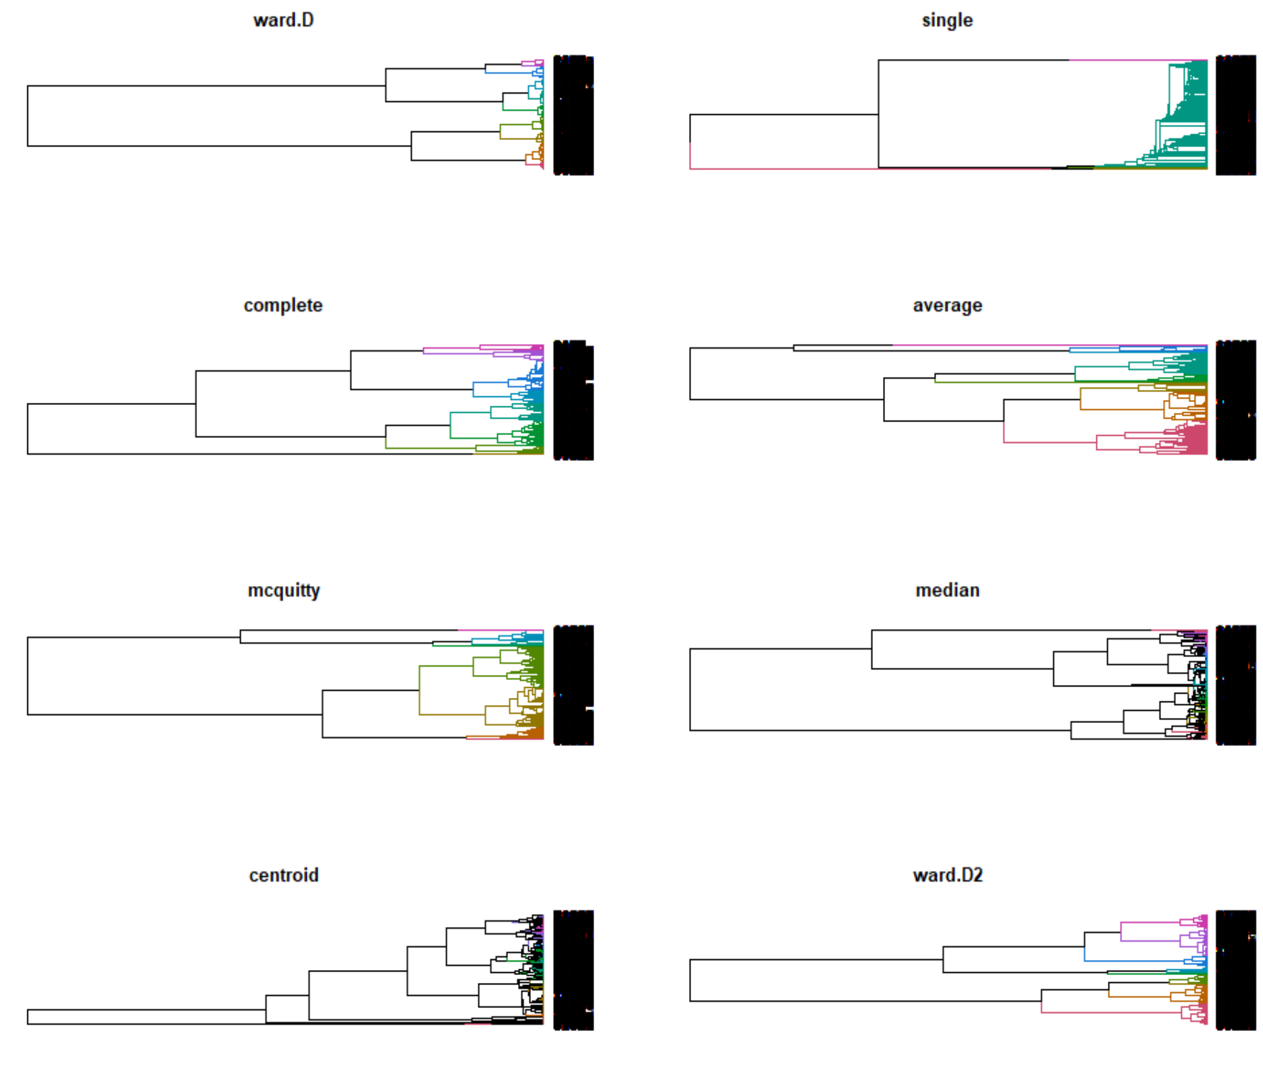

Each dendrogram looks quite different based on the method some slight similarities but we have different orders and colored clusters within our dendrograms. Looking at our dendrograms we can see that some appear to not be very clustered according to color, which is concerning and means the accuracy of that method is pretty poor. Based on the visualization it would appear that our most accurate methods were complete, average, mcquitty, and ward.D2. The worst looks to be single and centroid, and median all look like they had terrible performance.

**Conclusions of HCA**

After going through the entire HCA process it’s fair to conclude that the goal of the patient encounter and social determinant variables being able to cluster the data into the correct chronic conditions is tough and was unsuccessful. It appears we do get a lot of variation within our clusters based on our dendrograms but when we bring in the heat maps per variable based on the dendrograms performance it is pretty evident that the accuracy of the model overall was quite poor.

## K-Means Clustering

The objective of K-means is to group similar data points together and discover possible hidden patterns within the data.

How we will use k-means differently than the HCA method is that even though we will be looking at the entire dataset, we will only be pulling in a couple measures at a time and methodically trying to cluster the data based on those given variables. From our HCA we already know which variables have a relationship that has a strong probability of correlation.

Before we begin clustering our data it is wise to find the ideal value for k. This can be done by calculating and plotting the within group sum of squares and discovering the amount with what is called the elbow method. This method works by clustering on the dataset for a range of values for what k should be, then for each value of k an average score is configured for all the clusters and then plotted on the graph.

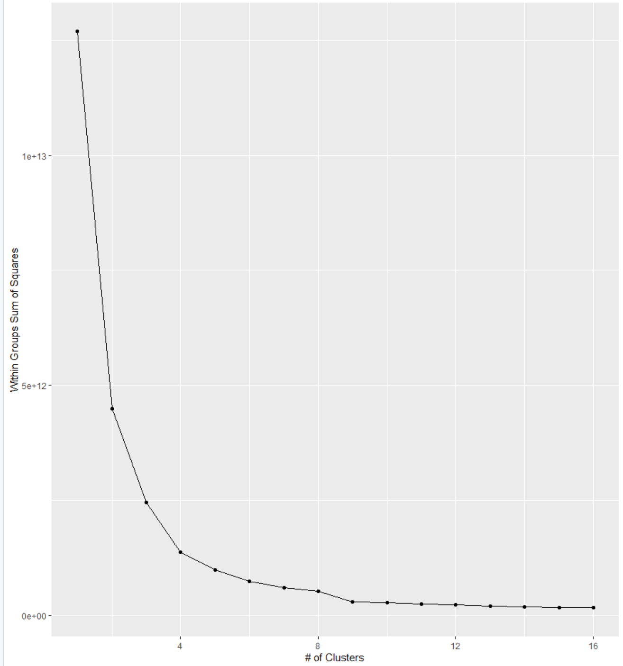

From our elbow chart above, it is a bit difficult to determine what is in fact our elbow. It is best to look at this like your are actually looking at a human arm. Our arm goes for k = 1-3, then we start to see diminishing returns at k = 4. Giving the appearance that this would be our elbow, but we get another drop at k = 9. For that reason, the k value I went with was k = 9.

Another aspect of k-means that will be within our plots is centroids. Centroids are just the center of our cluster, but can be important in mapping differences between clusters. Within each variable, the centroid will be different for the k value it is a assigned, think of it as either the x or y value when the variable is being plotted and the data is being clustered within it. Doing that with our 9 clusters we get values like this:

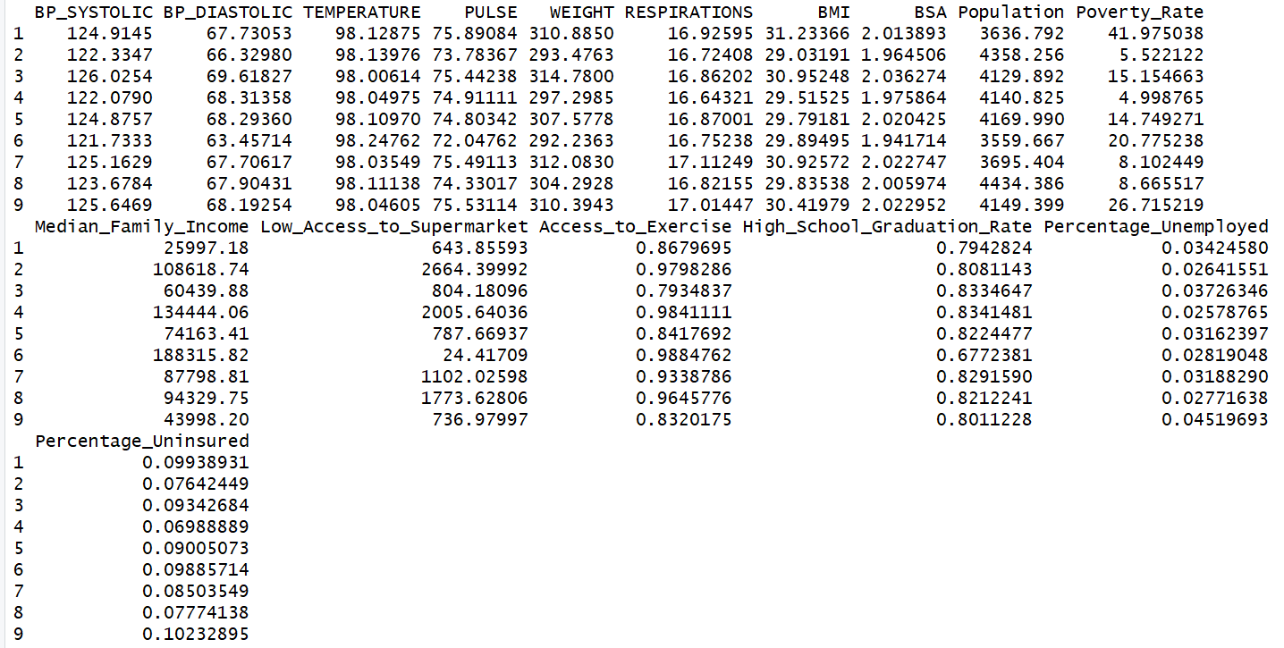

From these values, what we can see is a bunch of varying values for each variable and each value of k and what is also noticeable is the different variance seen with these variables, which will be interesting to note going forward.

It’s now time to plot our k-means charts, what I will focus on showing is some of the pairings which had the strongest correlation over this time.

**Positive Correlated Pairings:**

Weight vs. BMI

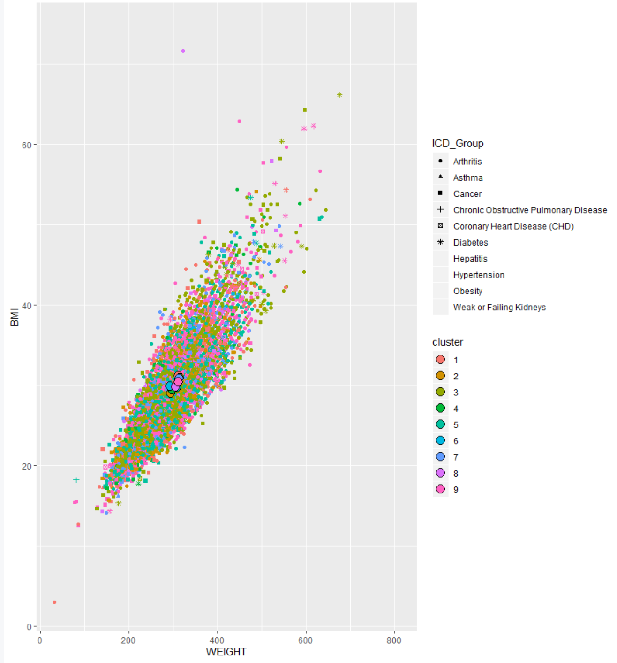

Though the data is positively correlated, there looks to be no differentiation between the clusters in way of each data point or their centroids.

Supermarket Access vs. Population

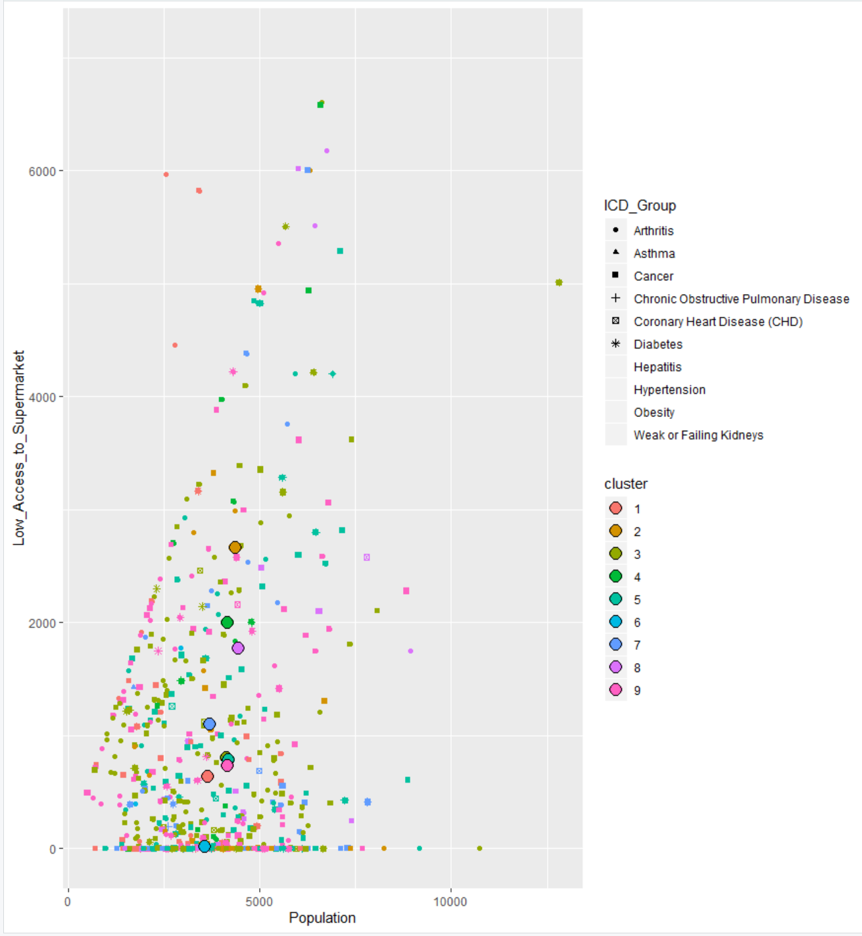

There is quite a split between each of the different centroids that is noticeable across the Supermarket Access variable, this is true with the population but not to the same extent. The data points however clustered heavily together despite these differences in the centroids.

Percentage Uninsured vs. Poverty Rate

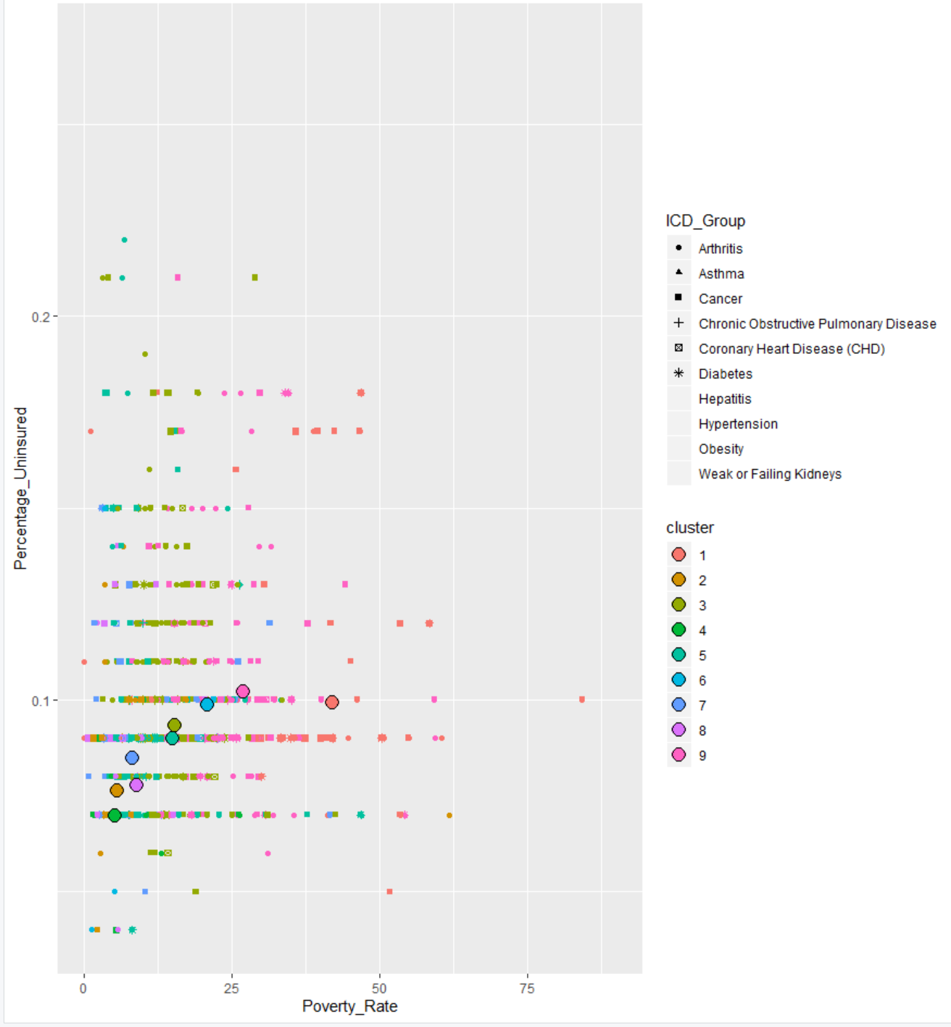

We do see a distinct cluster, with cluster 1 with all of its data points in the same area and its centroid well separated from the others. There are other promising bits of clustering happening within the data here as well just known so more evident than cluster 1.

**Negative Correlated Pairings:**

Poverty Rate vs. Median Family Income

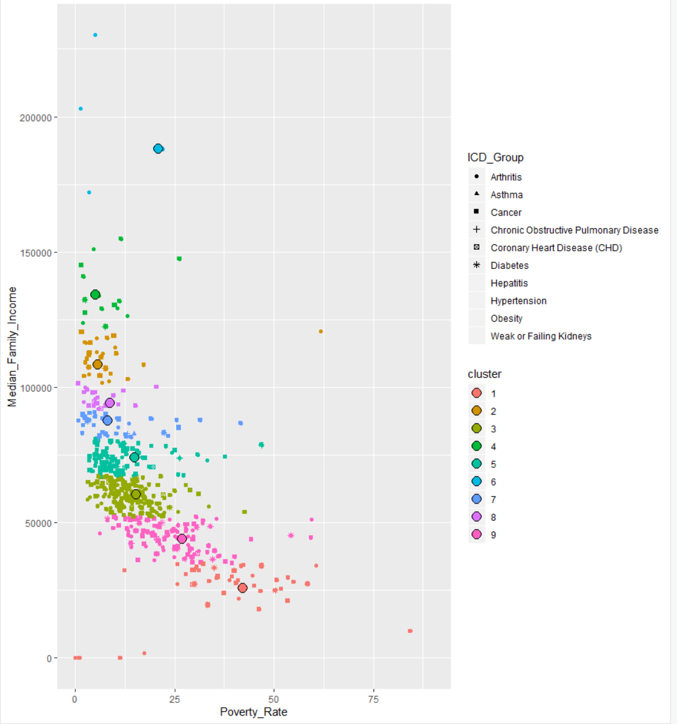

Truly a distinct clustering of each of the 9 here, it appears too that there is a drastic correlation between the two variables.

High School Grad Rate vs. Exercise Access

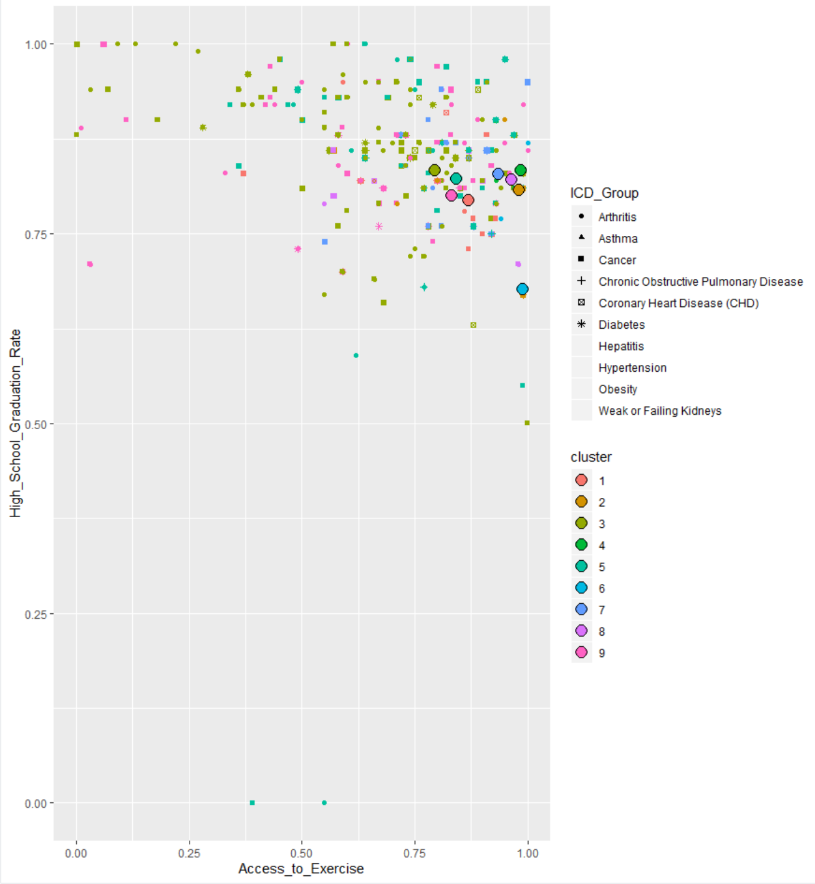

There are no real distinct clusters within the plot but cluster 6 looks significantly lower based on its centroid on the high school graduation rate than the others within the group.

% Uninsured vs. Median Family Income

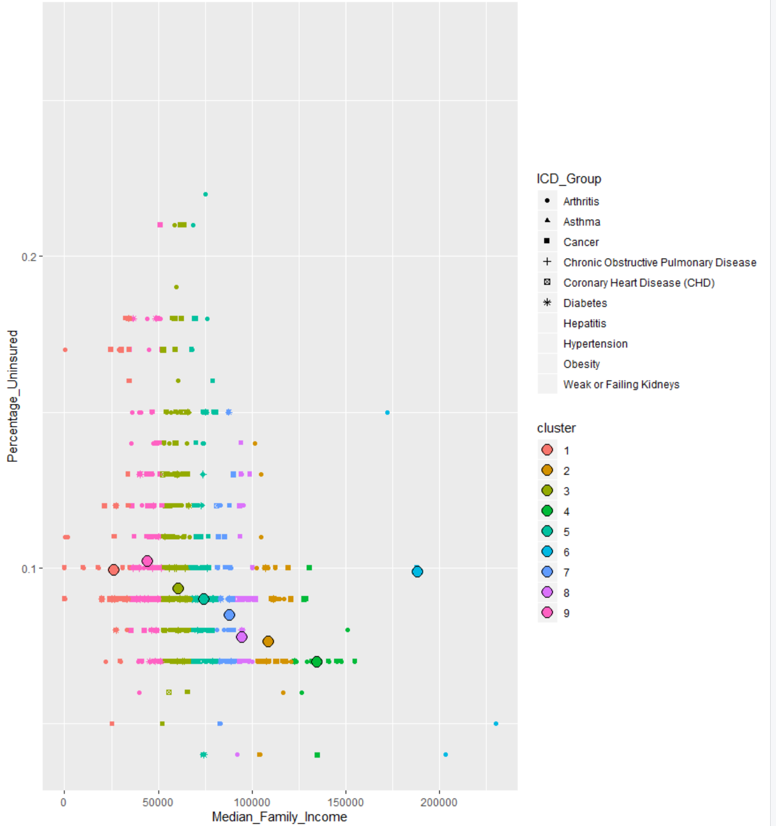

There are noticeable clustering and centroid separation thanks in large part to the median family income, the two variables also appear to have a strong negative correlation as well with cluster 6 being a bit of an outlier by its centroid being high in both median family income and percent uninsured.

### Conclusion:

From the K-means clustering it is easy to see that not very many variable pairings have a correlation so it is hard to pull meaningful information and uncover underlying patterns from all of them. Median Family Income consistently had the strongest pull of all variables and was able to pull our centroids out and cause some clustering to occur. I was discouraged to see that some of the shapes that were assigned to the different chronic conditions were intermingled into multiple clusters, which meant that each chronic condition had similarities that allowed them to be clustered together over each of our variables. Discouraging as the result may be however it doesn’t take away from the insights pulled from earlier parts of the entire project.

## Reflection:

Though there was some tangible information pulled from the project overall, when the unsupervised learning algorithms were brought in the results were underwhelming. There were signs of this early on within the EDA process. When I found that over 80% of patients were either arthritis or cancer, while the other 8 were less than 20% that should’ve been a sign that it would be difficult to cluster these data points together. If the distribution of patients per chronic condition was more even there could be a much greater chance at a cluster analysis working out but I think with what I had I exhausted each method to try and pull something out for them. I was encouraged by the entire EDA process in general though, I do believe that there is some social determinant data that is indeed having a negative affect on patients within their environment and I believe the Tableau Dashboards prove that on several occasions, especially when matching percentage of patients in a high stress environment potentially correlating to the disease they have. If I could make any changes I would start by having a more even distribution of patients to chronic condition, it in no means needs to be equal throughout but having arthritis have over 7000 patients and asthma have only 11 patients will never yield great results using these methods. I also believe it would have been a better study if I refined my patients to maybe one single type of chronic condition, and then try to compare that to a patient population at large. Isolating these diseases and looking at them singularly I believe could yield some amazing results. Going forward into Practicum 2 I believe my approach of refining to maybe just one single chronic condition will be my ally. I could do this with each of the chronic conditions I have but I believe starting with looking at a single chronic condition vs. an entire patient population could possibly pull a lot of information that can help impact the healthcare community.